Abstract

This project is concerned with prediction of time window within which a given device may fail, based on sensor values from sensors, which are fitted in the device and in areas of requirement, fed into our dataset. This is expected to save users from unexpected losses or chaos which might occur when the device fails without any prior warning and with no replacement at hand.

1. BASICS AND SKILL DEVELOPMENT

1.1 Overview with Hyperlinks:

1. Python Overview (especially numpy and pandas):

<https://www.tutorialspoint.com/python/>

1. Tensorflow study:
2. <http://learningtensorflow.com/>
3. [http://cs224d.stanford.edu/lectures/CS224d-Lecture7.pdf](http://cs224d.stanford.edu/lectures/CS224d-Lecture7.pdf )
4. <https://ml-with-tensorflow.info/>
5. Use of Gradient Optimizer to optimize a random linear model.

Example can be found here: <http://learningtensorflow.com/lesson7/>

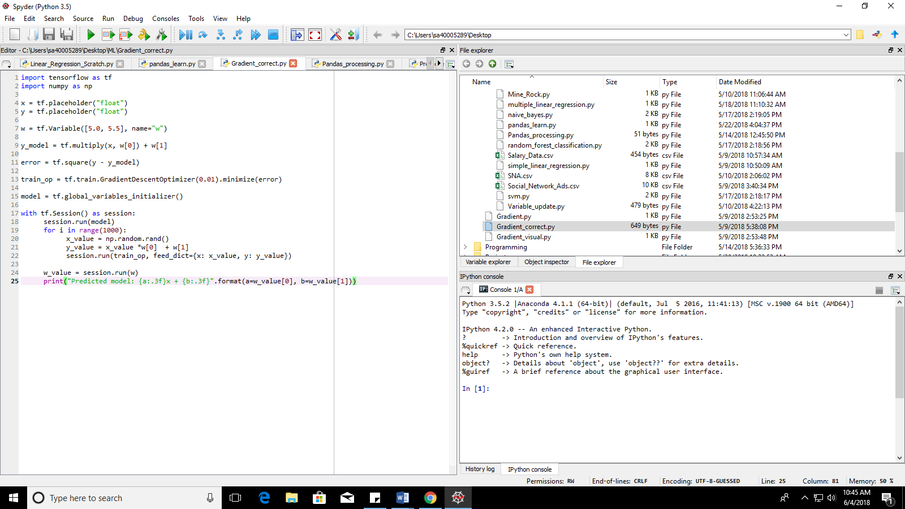

1. Gradient Optimizer code for Linear Regression written from scratch in python to grasp concept:

<https://github.com/samadrita1/ML/blob/master/Linear_Regression_Scratch.py>

1. Overview of popular regression and classification models (Udemy Tutorial)

<https://www.udemy.com/machinelearning/>

1. Used Tensorflow to implement K-Neighbors classification model

Example can be found here: <http://learningtensorflow.com/lesson6/>

1. Study of different loss functions and optimization techniques.

1.2 Detailed Report on Study:

1. Loss functions and their use (Overview)

* L1 regularization technique is called **Lasso Regression**. Adds “absolute value of magnitude” of coefficient as penalty term to the loss function. Lasso shrinks the less important feature’s coefficient to zero thus, removing some feature altogether. It works well for feature selection in case we have a huge number of features.
* L2 is called **Ridge Regression**. Ridge regression adds “squared magnitude” of coefficient as penalty term to the loss function. If lambda is zero, then you can imagine we get back ordinary least square. However, if lambda is very large then it will add too much weight and it will lead to under-fitting. Works very well to avoid over-fitting issue.
* Regressive loss functions

1. **Mean Square Error**/Ridge: measures the average of the squares of the **errors** or deviations—that is, the difference between the estimator and what is estimated  
   MSE= 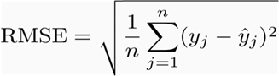
2. **Mean Absolute Error**/Lasso: It is the absolute difference between the measured value and “true” value. It decreases the weight for outlier errors.

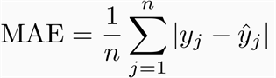

1. **Smooth Absolute Error**: It is the absolute difference between the measured value and “true” value for predictions lying close to real value and it is the square of difference between measured and “true” value for outliers (or points far off from predicted values). Basically, it is a combination of MSE and MAE.

* Classification loss functions: Misclassification measures

<https://en.wikipedia.org/wiki/Loss_functions_for_classification>

1. **0-1 loss function**: this is basically it: you count the number of misclassified items. There is nothing more behind it, it is a very basic loss function. For instance, it can be determined from confusion matrix which shows number of misclassifications and correct classifications. penalizes misclassification, it assigns the smallest loss to the solution that has greatest number of correct classifications.
2. **Hinge loss function** (L2 regularized): The hinge loss is used for "maximum-margin" classification, most notably for [support vector machines](https://en.wikipedia.org/wiki/Support_vector_machine) (SVMs). Basically, it measures squared difference between the drafted margin between the classes and the margins passing through the nearest points in the classes on either side.

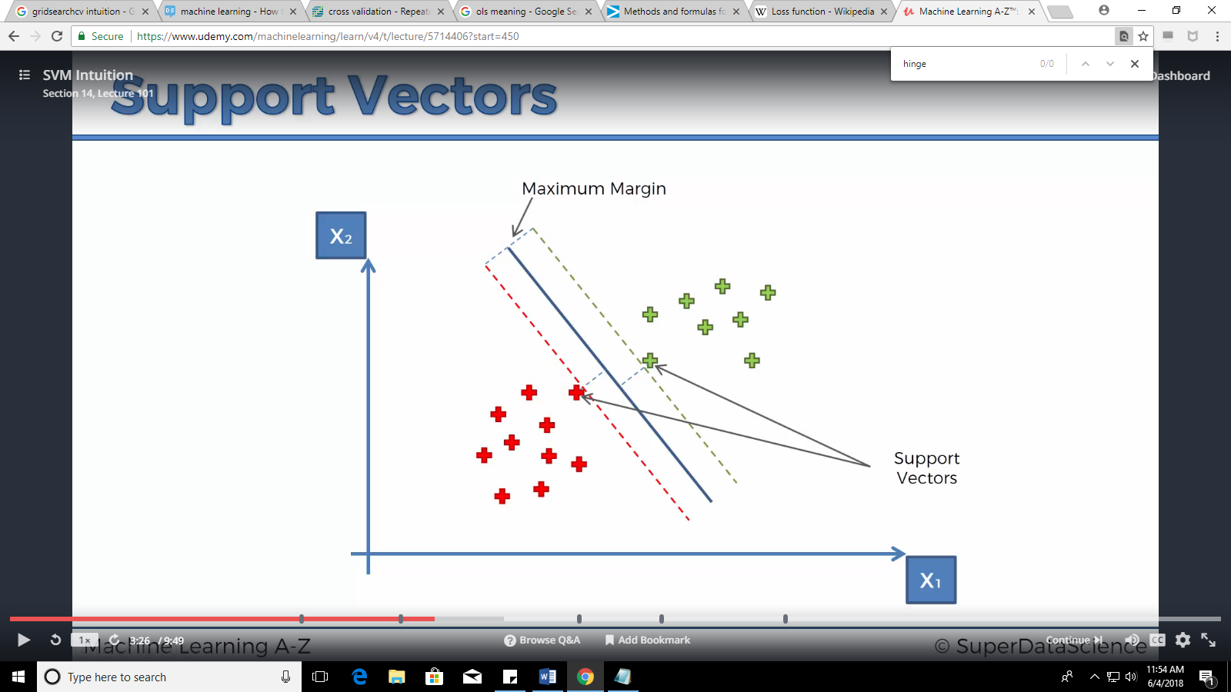

Source: Udemy

Disclaimer: All materials from Udemy are to be strictly protected and viewed only for educational purpose, and must not be used for publication or commercial purposes.

1. **Logistic Loss**: This function displays a similar convergence rate to the hinge loss function, and since it is continuous (unlike Hinge Loss), [gradient descent](https://en.wikipedia.org/wiki/Gradient_descent) methods can be utilized. However, the logistic loss function does not assign zero penalty to any points. Instead, functions that correctly classify points with high confidence are penalized less. This structure leads the logistic loss function to be sensitive to outliers in the data.
2. **Cross entropy/log loss**: or log loss, measures the performance of a classification model whose output is a probability value between 0 and 1. Cross-entropy loss increases as the predicted probability diverges from the actual label.

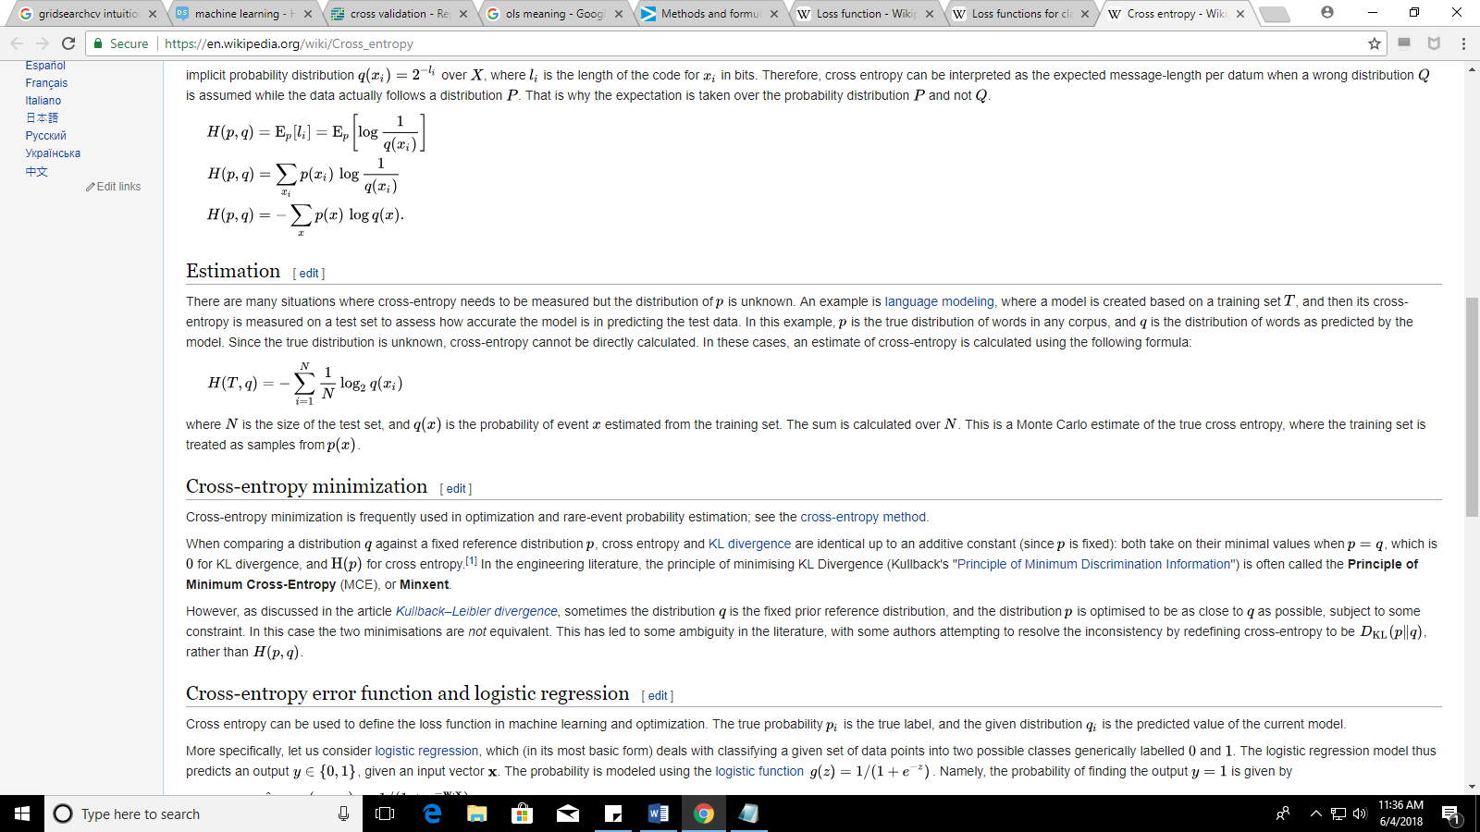

There are several other loss functions, only the primary ones, depending on the study, have been explained here.

1. **Optimization functions** (Overview)

[https://towardsdatascience.com/](https://towardsdatascience.com/gradient-descent-algorithms-and-adaptive-learning-rate-adjustment-methods-79c701b086be)

* **Constant Learning Rate Algorithms**

**Challenges:**

* Choosing a proper learning rate can be difficult. A learning rate that is too small leads to painfully slow convergence, while a learning rate that is too large can hinder convergence and cause the loss function to fluctuate around the minimum or even to diverge.
* The same learning rate applies to all parameter updates. If our data is sparse and our features have very different frequencies, we might not want to update all of them to the same extent, but perform a larger update for rarely occurring features.

Stochastic Gradient Descent: Optimum results not obtained, computationally inexpensive. Performs a parameter update for each training.

Batch gradient descent: Computes the gradient of the cost function w.r.t. to the parameters θ for the entire training dataset.

Mini-batch gradient descent:Mini-batch gradient descent finally takes the best of both worlds and performs an update for every mini-batch of n training examples.

* Adaptive Learning Rate Algorithms

Advantage: Parameters modified/adapted with iterations. Manual intervention is minimum.

Adagrad: Good results. Adagrad adapts updates to each individual parameter to perform larger or smaller updates depending on their importance.

Disadvantage: computationally expensive

Adam: Faster than Adagrad with good results, Adaptive Moment Estimation is most popular today.

Disadvantage: Computationally expensive

1. **Supervised Learning Algorithms** (Intuition + loss functions mostly used)

* **Support Vector Machines:**

A Support Vector Machine (SVM) is a supervised machine learning algorithm that can be employed for both classification and regression purposes. SVMs are based on the idea of finding a hyperplane that best divides a dataset into two classes

Loss function: Hinge Loss

Intuition:

* + - * + Supposing we have a space of n dimensions. We can write down an equation describing an n-1 dimensional object that divides the n-dimensional space into two spaces/parts. This object is called a hyperplane. For example, in a 2-D [n-D] graph, a 1-D [(n-1)-D] line effectively separates it into 2 parts.
        + Support vectors are the data points nearest to the hyperplane, the points of a data set that, if removed, would alter the position of the dividing hyperplane. Because of this, they can be considered the critical elements of a data set.
        + The distance between the hyperplane and the nearest data point from either set is known as the margin.
        + The goal is to choose a hyperplane with the greatest possible margin between the hyperplane and any point within the training set, giving a greater chance of new data being classified correctly.

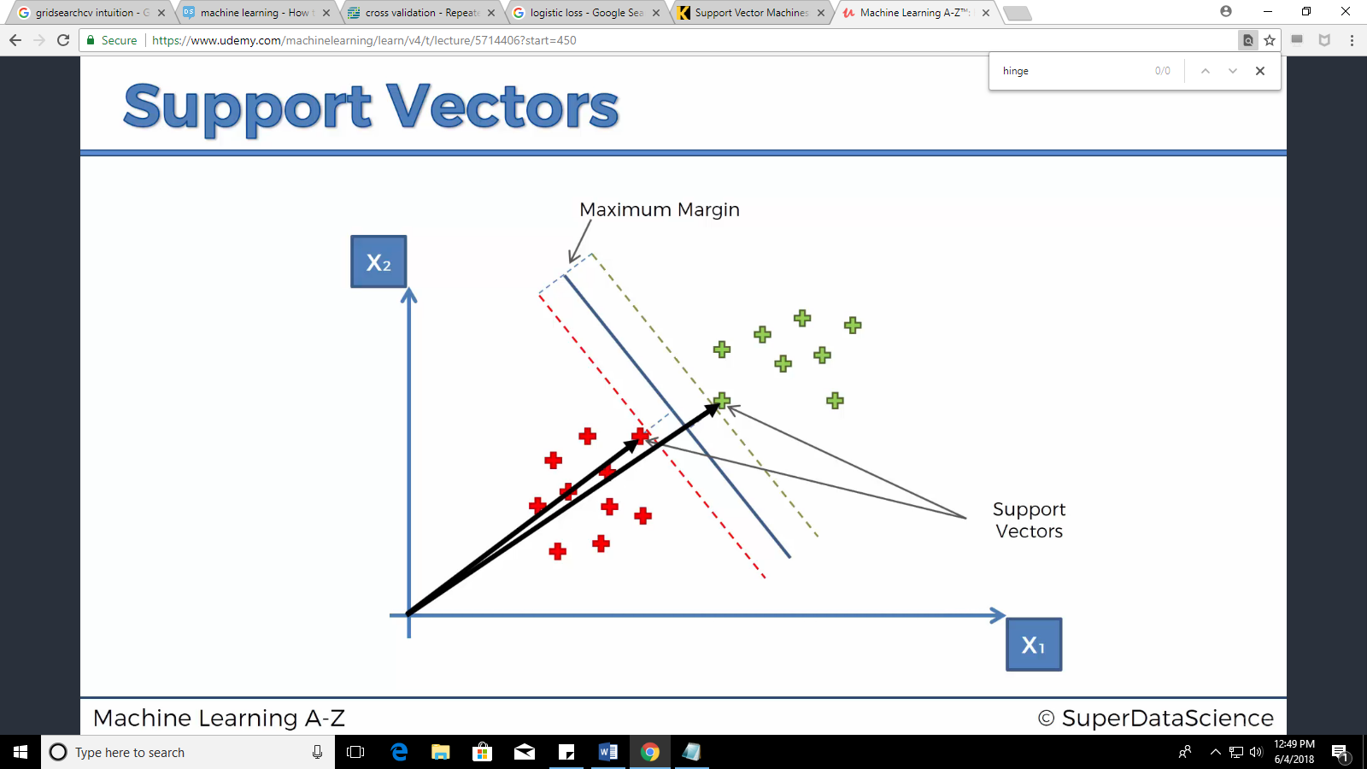

Source: Udemy

Pros

Accuracy

Works well on smaller cleaner datasets

It can be more efficient because it uses a subset of training points

Handles high dimensional data well

Cons

Isn’t suited to larger datasets as the training time with SVMs can be high

Less effective on noisier datasets with overlapping classes

Code: [svm.py](https://github.com/samadrita1/ML/blob/master/svm.py)

[Read for mathematical understanding](https://towardsdatascience.com/support-vector-machines-intuitive-understanding-part-1-3fb049df4ba1)

[Primary Source](https://www.kdnuggets.com/2016/07/support-vector-machines-simple-explanation.html)

* **Logistic regression**:

Loss function: Cross-Validation/Log loss

Intuition:

* + - * + For classification problems which have binary numbers in the target feature, we cannot use linear regression models since that will lead to huge square loss.
        + Instead, if we manipulate the regression equation such that the shape of the plot is inclined towards the data points, we will face minimal resistance from the error function.
        + This can be done by applying the sigmoid function as follows:

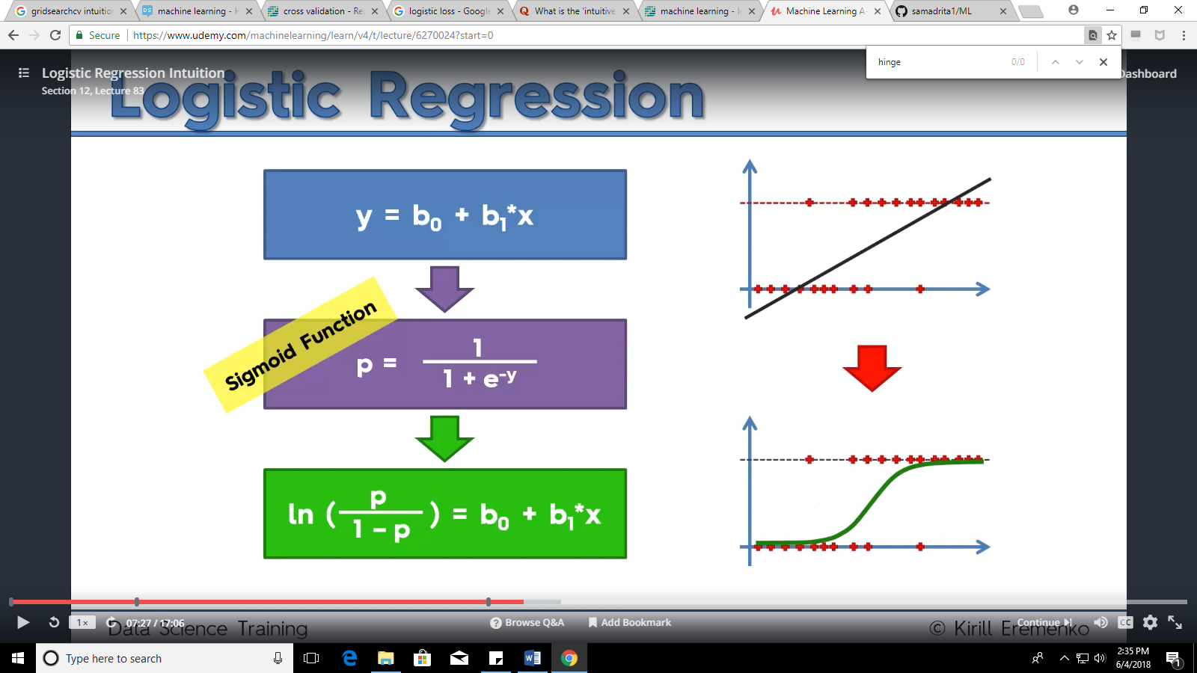

Source: Udemy

* + - * + This plotted line basically measures the probability of each point to be in a certain class (Class:0 or Class:1)

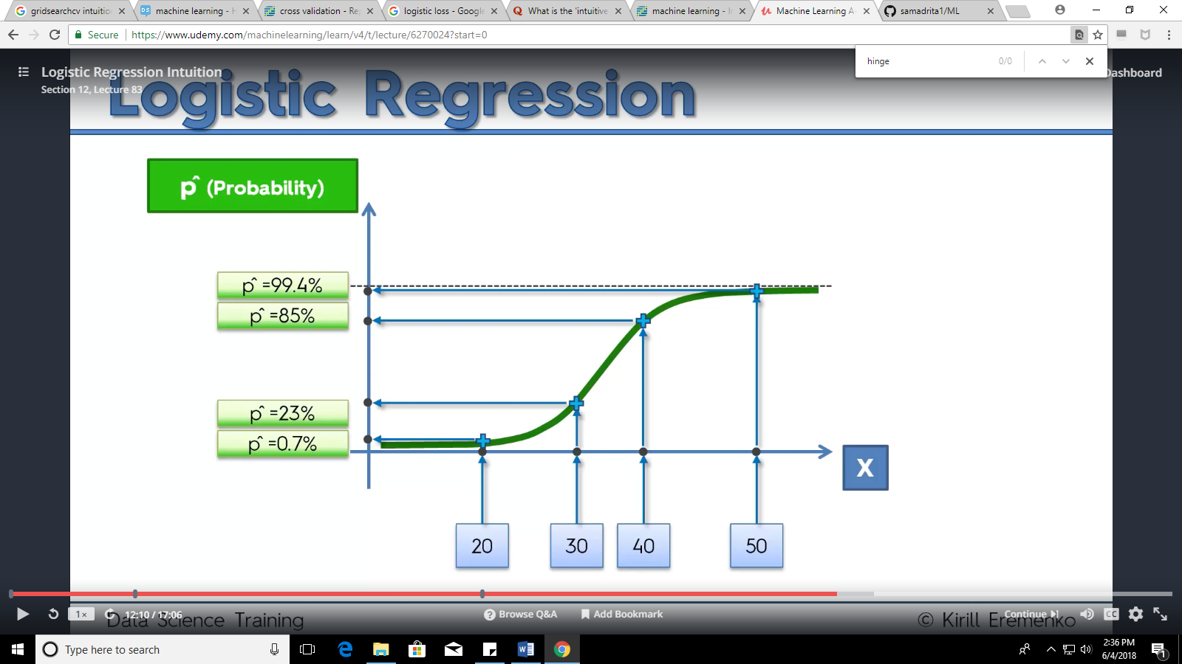

**Source: Udemy**

* + - * + The default threshold probability is 0.5. Probability of the point being in class:1 above 0.5 classifies the point under class:1 and lower than 0.5 classifies it under Class:0

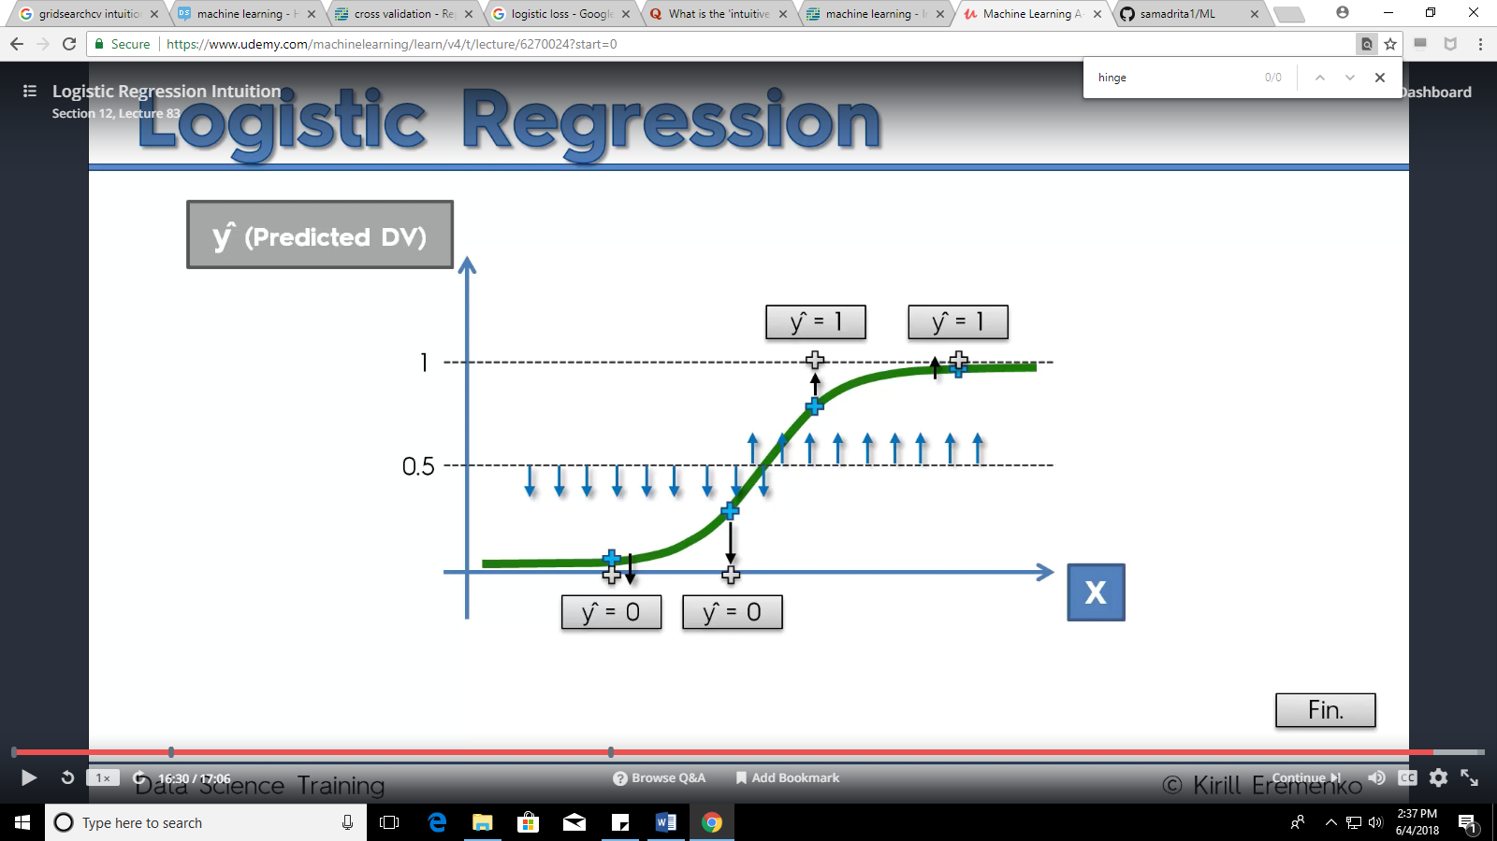

**Source: Udemy**

Pros:

Convenient probability scores for observations

Efficient implementations available across tools

Multi-collinearity is not really an issue and can be countered with L2 regularization to an extent

Wide spread industry comfort for logistic regression solutions [ oh that’s important too!]

Cons:

Doesn’t perform well when feature space is too large

Doesn’t handle large number of categorical features/variables well

Relies on transformations for non-linear features

Code: [Logistic Regression using Scikit Library](https://github.com/samadrita1/ML/blob/master/logistic_regression.py), [Logistic Regression using Tensorflow](https://github.com/samadrita1/ML/blob/master/logistic_tensy_better.py)

[Primary Source](https://www.udemy.com/machinelearning/), [Secondary Source](https://www.edvancer.in/logistic-regression-vs-decision-trees-vs-svm-part2/)

* **Naive Bayes:**

Loss function: 0-1 Log Loss

Intuition:

* + - * + Naïve Bayes aims to calculate the posteriori probability of a data point belonging to a certain class. It does so by calculating three types of probability (as under)

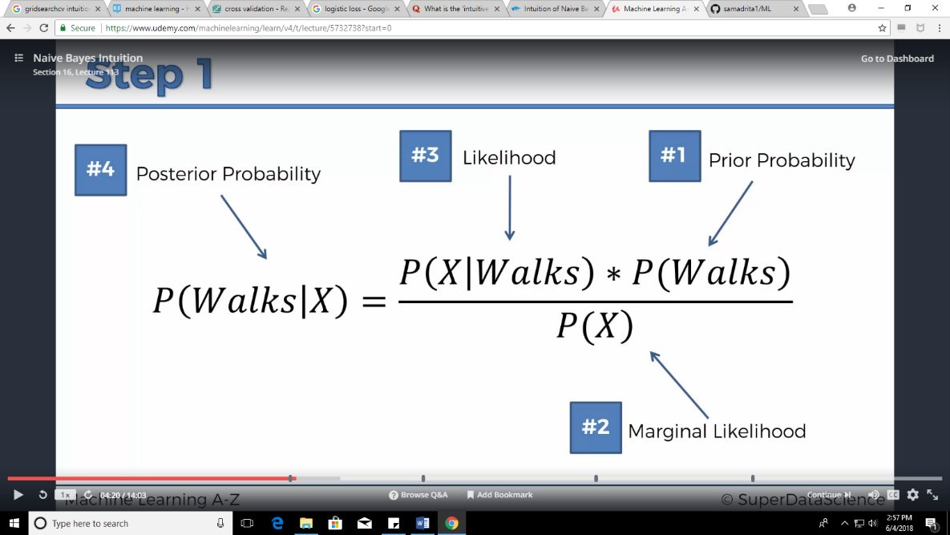

Source: Udemy

* + - * + Prior probability is the probability of a point being in class: Red when the entire set of data points are considered.

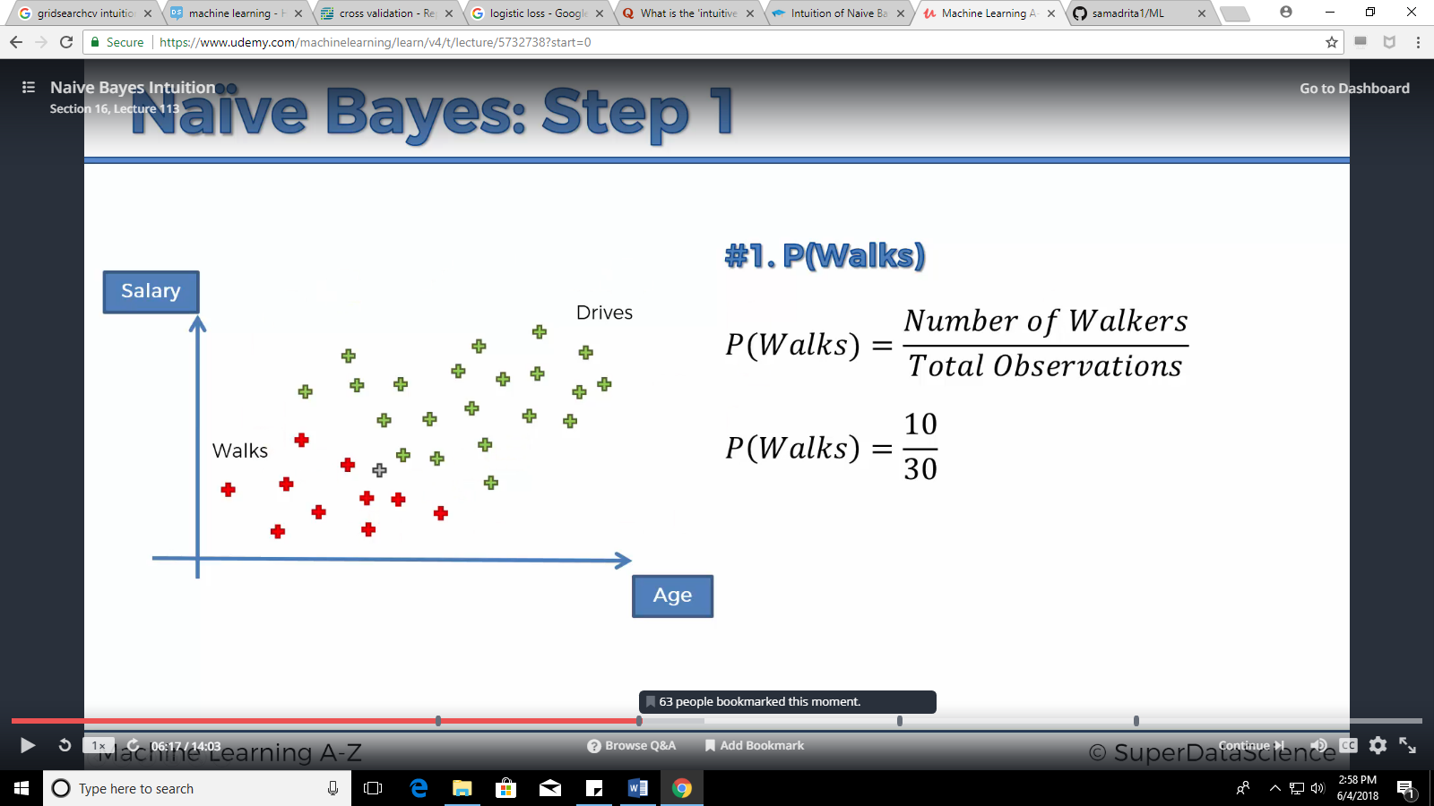

Source: Udemy

* + - * + Marginal likelihood is the probability of a point belonging to the selected area

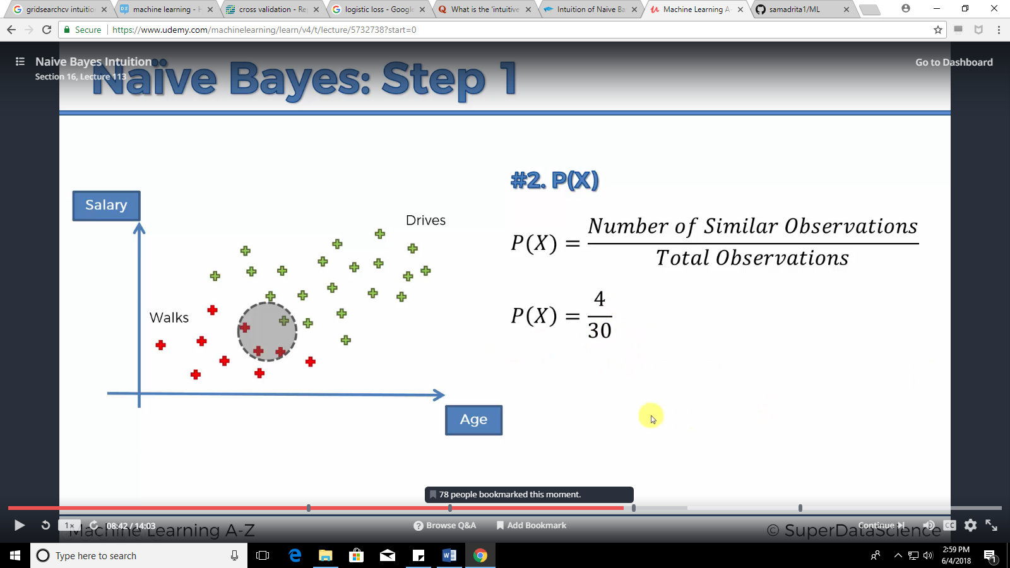

Source: Udemy

* + - * + Likelihood is the probability of a point from class: Red being in the selected area

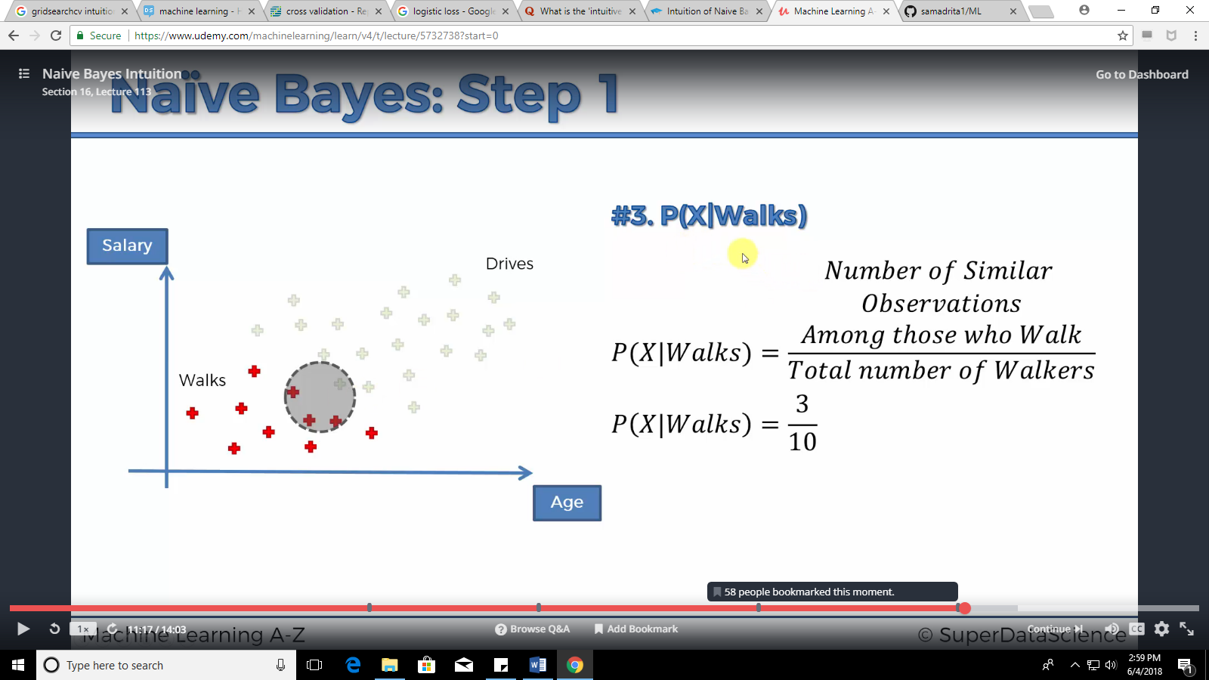

Source: Udemy

* + - * + These values are used in the equation to determine the probability of a new point in the marginal area selected to be in class: Red (Posterior Probability)

Pros:

Computationally fast

Simple to implement

Works well with high dimensions

Cons:

Relies on independence assumption (assumption that the features are independent of each other) and will perform badly if this assumption is not met

Code: [naive_bayes.py](https://github.com/samadrita1/ML/blob/master/naive_bayes.py)

[Primary Source](https://www.udemy.com/machinelearning/)

* **Decision trees:**

Intuition:

“*Decision tree is a type of supervised learning algorithm. It works for both categorical and continuous (regression) input and output variables. In this technique, we split the population or sample into two or more homogeneous sets (or sub-populations) based on most significant splitter / differentiator in input variables.”*

Source: [medium.com](https://medium.com/greyatom/decision-tree-intuition-a38669005cb7)

* + - * + Decision trees use a criterion (there are multiple criteria available) to decide to split a node in two or more sub-nodes
        + The creation of sub-nodes increases the homogeneity of resultant sub-nodes. In other words, we can say that purity of the node increases with respect to the target variable
        + Decision tree splits the nodes on all available variables and then selects the split which results in most homogeneous sub-nodes.

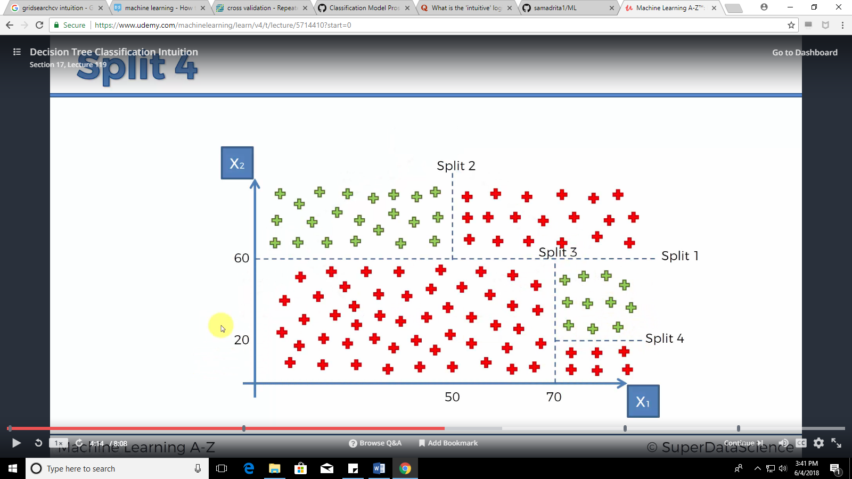

Source: Udemy

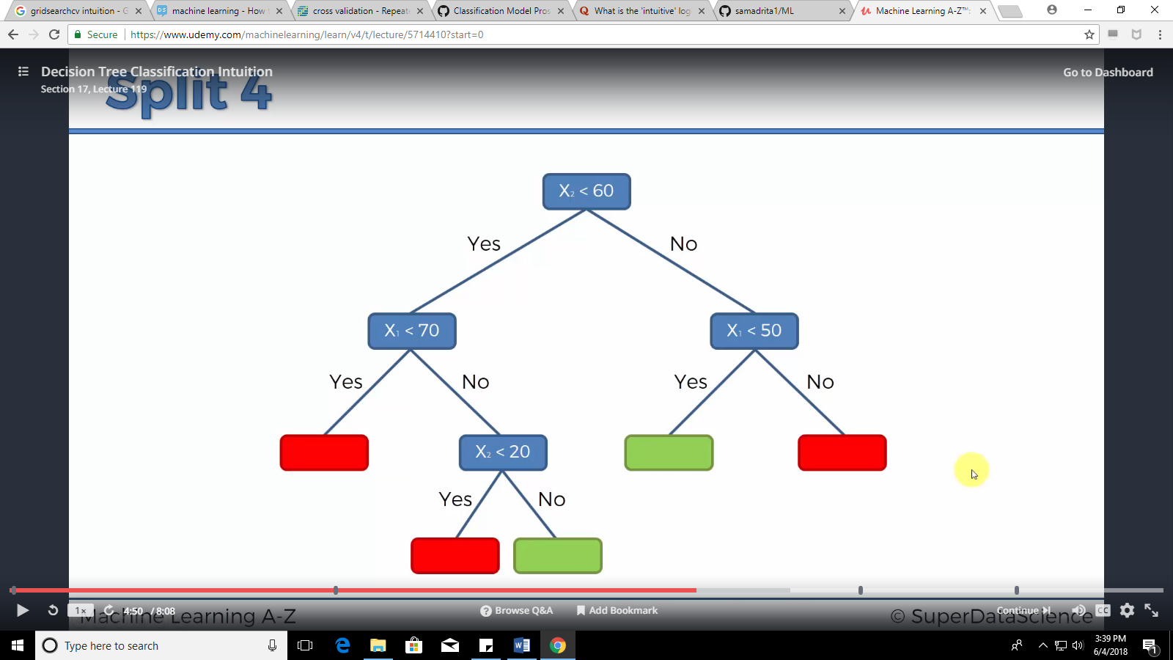

Source: Udemy

Pros:

Requires little data preparation

Can handle both numerical and categorical data

Able to handle multi-class problems

Possible to validate model using statistical tests, thus high accountability and reliability

Cons:

May lead to overfitting

Not fit for continuous variables

Code: [decision_tree.py](https://github.com/samadrita1/ML/blob/master/decision_tree_classification.py)

[Primary Source](https://medium.com/greyatom/decision-tree-intuition-a38669005cb7)

* **Random Forest Classification**

Intuition:

Consider an election where every citizen votes for electing a member for a public office. In this case, every vote4s will be considered as a decision tree. They evaluate the consequences of electing either person A or B and comes to a conclusion regarding who will be better. The person who counts the votes is the Random Forest. He looks at every decision coming from every person (tree), accumulates them and declares the candidates based on the majority.

In random forest ‘n’ number of decision trees are generated where ‘n’ results regarding the category of a certain data point (the target variable) are established. The category which has majority votes among all the decision trees in the ‘Forest’ shall win and the data point in question shall be categorized under that particular category.

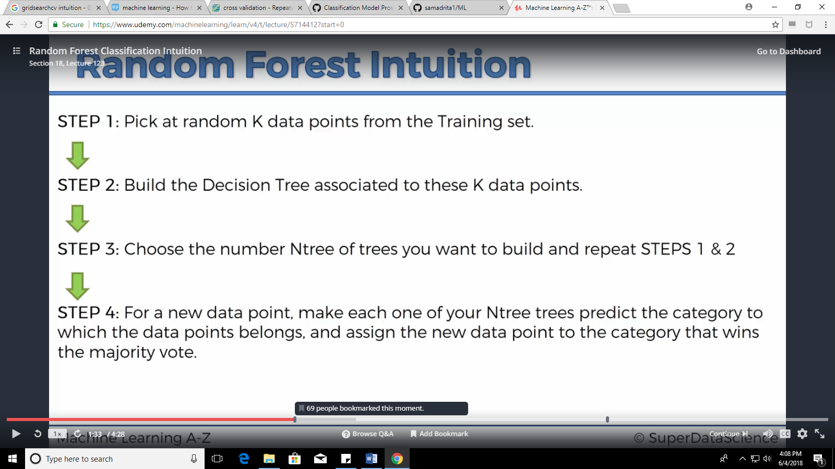

Source: Udemy

For a more intuitive understanding, refer to the blog: <https://www.datasciencecentral.com/profiles/blogs/random-forests-explained-intuitively>

Pros:

Important when dealing with multiple features which may be correlated

Reduced Variance (Compared to regular trees)

Cons:

Difficult to interpret visually

Code: [random_forest.py](https://github.com/samadrita1/ML/blob/master/random_forest_classification.py)

[Primary Source](https://medium.com/greyatom/decision-tree-intuition-a38669005cb7)

* **K-Nearest Neighbor**

Loss function: Exponential loss, Classification error, Hinge loss, Logit loss

Intuition:

If we plot given data points on a graph, we may be able to locate some clusters, or groups. Now, given an unclassified point, we can assign it to a group by observing what group its nearest neighbors belong to. This means, a point close to a cluster of points classified as ‘Red’ has a higher probability of getting classified as ‘Red’.

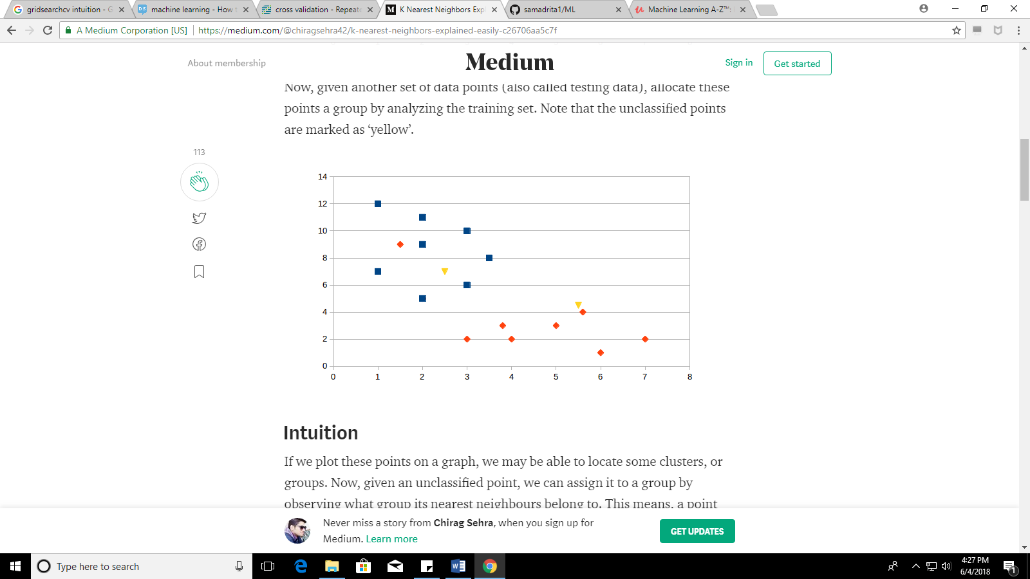

Source: Medium

Intuitively, we can see that the first point (2.5, 7) should be classified as ‘Blue’ and the second point (5.5, 4.5) should be classified as ‘Red’.

Pros:

High accuracy

insensitive to outliers

no assumptions about data

Cons:

Computationally expensive

requires a lot of memory

Code: [Using Scikit](https://github.com/samadrita1/ML/blob/master/knn.py), [Using Tensorflow](https://github.com/samadrita1/ML/blob/master/knn_tensy.py)

[Primary Source](https://medium.com/@chiragsehra42/k-nearest-neighbors-explained-easily-c26706aa5c7f), [Secondary Source](https://mariuszprzydatek.com/2014/05/27/k-nearest-neighbors-knn-algorithm-machine-learning/)

1. Gradient Descent and Minimize Function

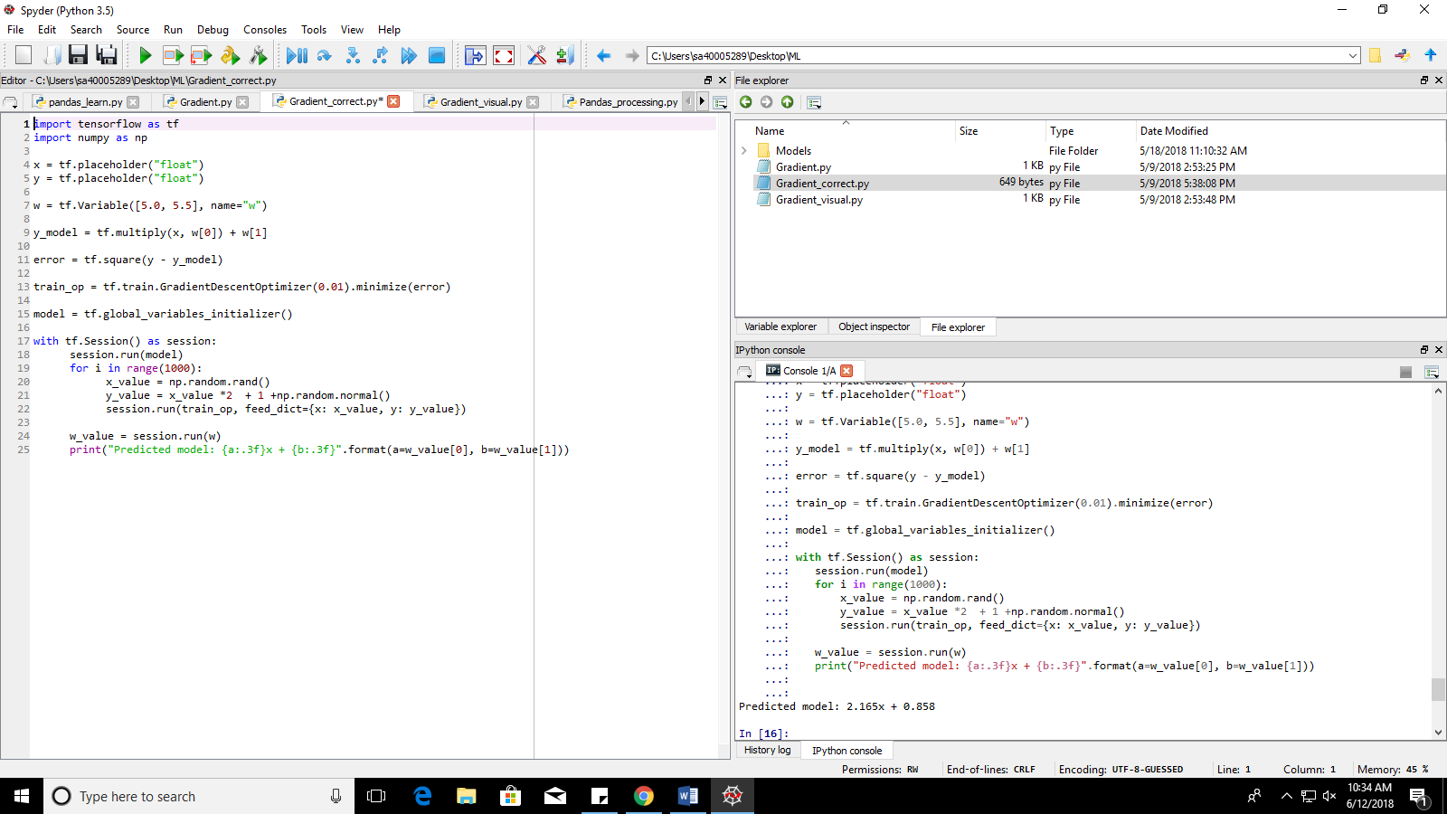

y_model (line: 9) takes in random values (here: slope=5.0 and constant=5.5). y_value (line:21) and x_value (line: 20) gives the original data points. The work of the Gradient optimizer is to align the y_model (= 5.0*x +5.0) with the original value: y_value.

Error (line:11) evaluates the square differences (or errors) between the original points (y_value) and the predicted y_model.

The work of the minimize function (line: 13) is to minimize the square differences between the y_model and y_value (the predicted and real values). Its primary parameter is a loss function and the choice of the loss function depends on the programmer. Here, square loss function has been used.

The GradientDescentOptimizer (line: 13) is in charge of introducing changes in the parameters (slope and constant) depending on the learning rate (here: 0.01). The choice of learning rate must a balanced choice. A too high value will result in missing out the optimum model and cause unnecessary fluctuations while deciding the optimum model. A too low value will result in extremely slow learning and relatively higher computational expenses.

The result or predicted model of this optimizing program is as follows:



Further details: <https://www.tensorflow.org/api_docs/python/tf/train/GradientDescentOptimizer>

1. Linear Regression using Gradient Descent (Code Understanding)

Steps to follow:

1. Create rough model with arbitrary weight and bias
2. Calculate Loss (Mean Square Error)
3. Minimize loss
4. Optimize the loss to arrive at the minima
5. Apply obtained weight and bias to predicted model

Link to Code: <https://github.com/samadrita1/ML/blob/master/Linear_regressor_tensy.py>

1. Preprocessing of Dataset and feeding into Linear Regression Model

Conversion of dataset to required format is of vital importance. It is suggested that programmer should check the ‘type’ of the parameters of optimizer and minimizing functions before feeding raw data to them.

1. Import dataset (through pandas)
2. Split into training and testing datasets (through Scikit learn)
3. Transform the data obtained into required format (like array or list of suitable shape)

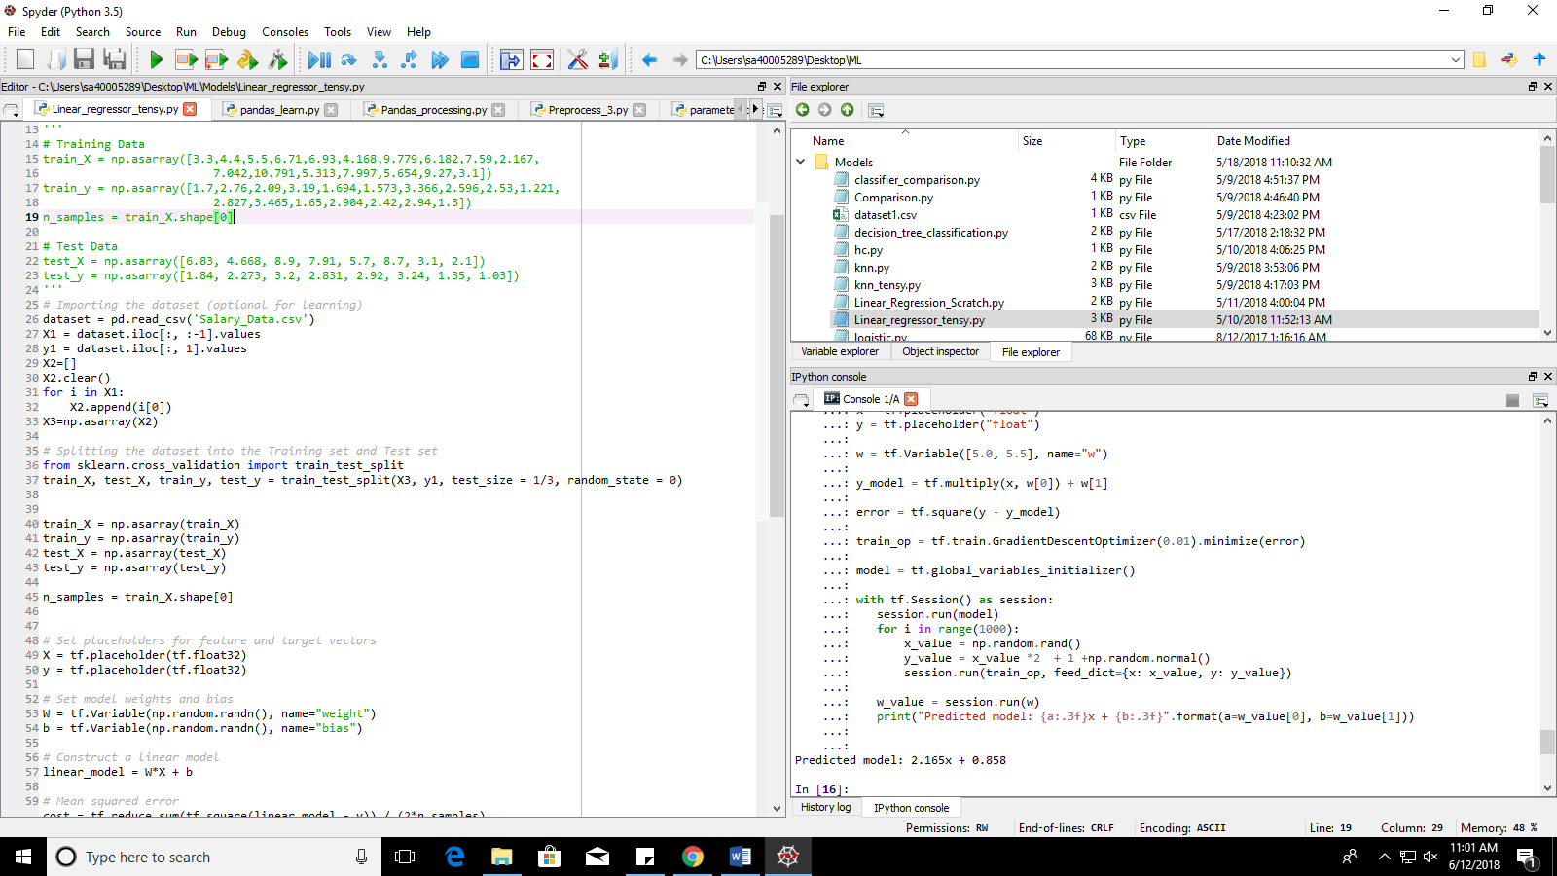

For learning purpose, the rough data marked in green can be used. They are generated in the required format.

1. Built Linear Regression in Python without Optimize or Minimize functions

Writing this code will help us to generate the descent optimizer and minimize functions from scratch, thus, broadening our understanding of the said functions. The steps to generate the same, are as under:

1. Create rough model with arbitrary weight and bias
2. Calculate Loss (Mean Square Error)
3. Update weight and bias by certain values
4. Calculate new Loss
5. Compare new Loss with previous loss
6. If less, continue to shift weight and bias in same direction
7. If more, shift weight and bias to opposite direction
8. After n iterations, apply obtained weight and bias to predicted model

The iterations are vital and if we visualize the predicted model after every few iterations, we see the predicted model getting aligned eventually towards the original alignment of the data points.

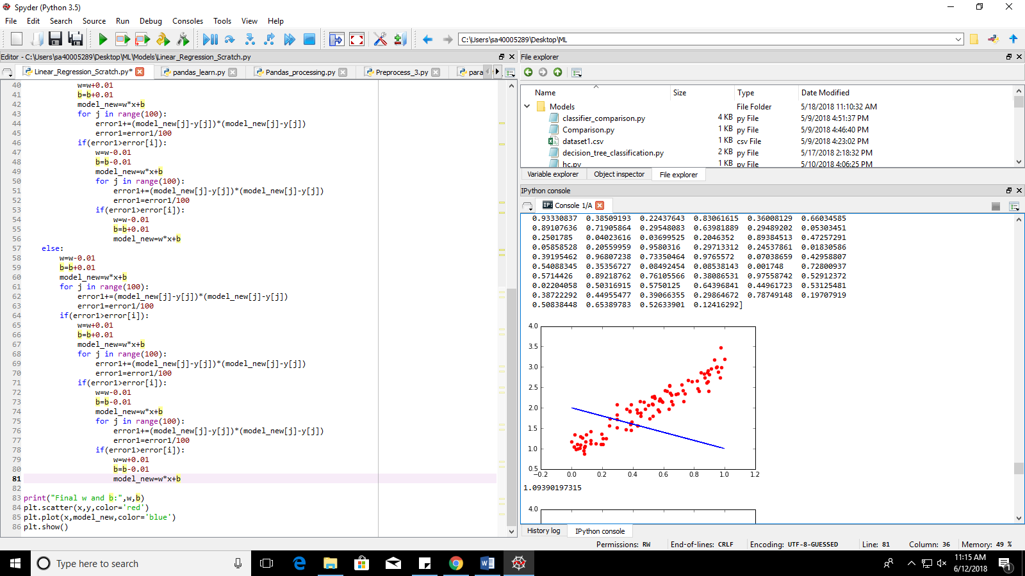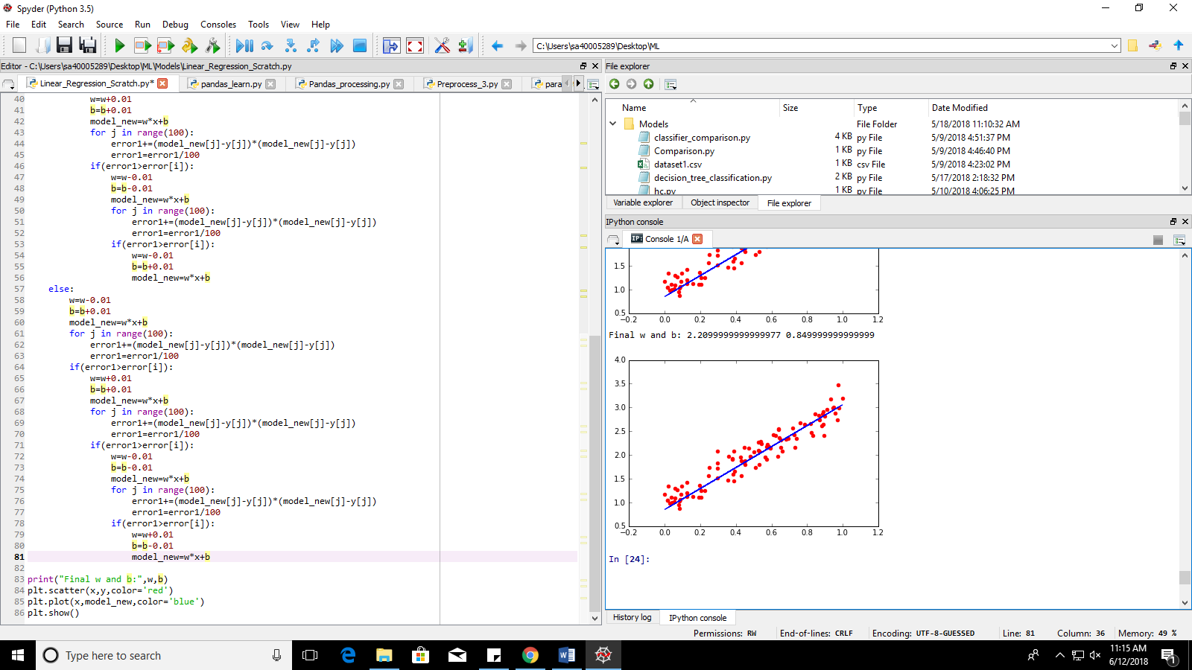

1st figure shows arbitrary model and the 2nd figure shows the predicted model after n-iterations.

Link to code: <https://github.com/samadrita1/ML/blob/master/Linear_Regression_Scratch.py>

1. Tensorflow Basics: Placeholder, Variables, Constants, Segmentation, Matrix operations

<http://learningtensorflow.com/>

1. Compare several models with different random patterns and visualize them to test which gives best fit (for learning purpose)



Source: <http://scikit-learn.org/stable/auto_examples/classification/plot_classifier_comparison.html>

Detailed Study: <https://www.sciencedirect.com/science/article/pii/S2212567112001748>

2. PREPROCESSING

2.1 Overview (Walkthrough):

1. Read entire dataset into pandas dataframe
2. Subtract the columns with garbage and raw values, use only the normalized columns’ data, remove the rest of the columns except SMART_9_raw
3. Store the serial numbers of the devices which failed (Since the machine can only learn the failure patters from devices which actually failed). The patterns studied can later be used to judge devices which haven’t failed yet)
4. Create new dataset with all instances(rows) of the devices which failed.
5. Remove all the nan values by replacing them with interpolated and extrapolated values based on the feature in question and the time the device has been serving.
6. Remove columns which still has all values as nan since the values in these columns can neither be interpolated nor extrapolated
7. Check variance of the remaining columns. Remove the columns with variance==0 (Variance is used to check the variety of data in a column. If variance=0, it means that the data across a column remains constant)
8. Check mutual Information score of each feature with the target variable. Remove features with score==0 (Mutual information is used to detect any form of relationship between two given parameters, if mutual information is 0, it means there is no dependency of the target variable with the feature or vice versa)
9. Check mutual information with remaining time (SMART_9_raw) since it is important for the features to vary over time in the failing devices
10. Add new column ‘RUL’ (remaining useful life) by subtracting ‘smart_9_raw’ values from ‘smart_9_raw’ value with class:1 (1 indicates failing instance/row) of the respective serial number (device)
11. Add new column ‘Label’ which places ‘1’ in all rows with ‘RUL’ value <= 240 hours (10 days) and ‘0’ in all rows with ‘RUL’ value > 240 hours
12. Apply recursive feature elimination on the obtained dataset to obtain ‘n’ best features
13. Divide the final dataset into training and testing sets

2.2 Detailed Report on Experimentation:

1. Reading of dataset using pandas library.

Pandas is a highly efficient library which helps us manage and visualize datasets with extreme clarity and ease. Given under is a cheat sheet to demonstrate most of the functions which have been used in the program to follow:

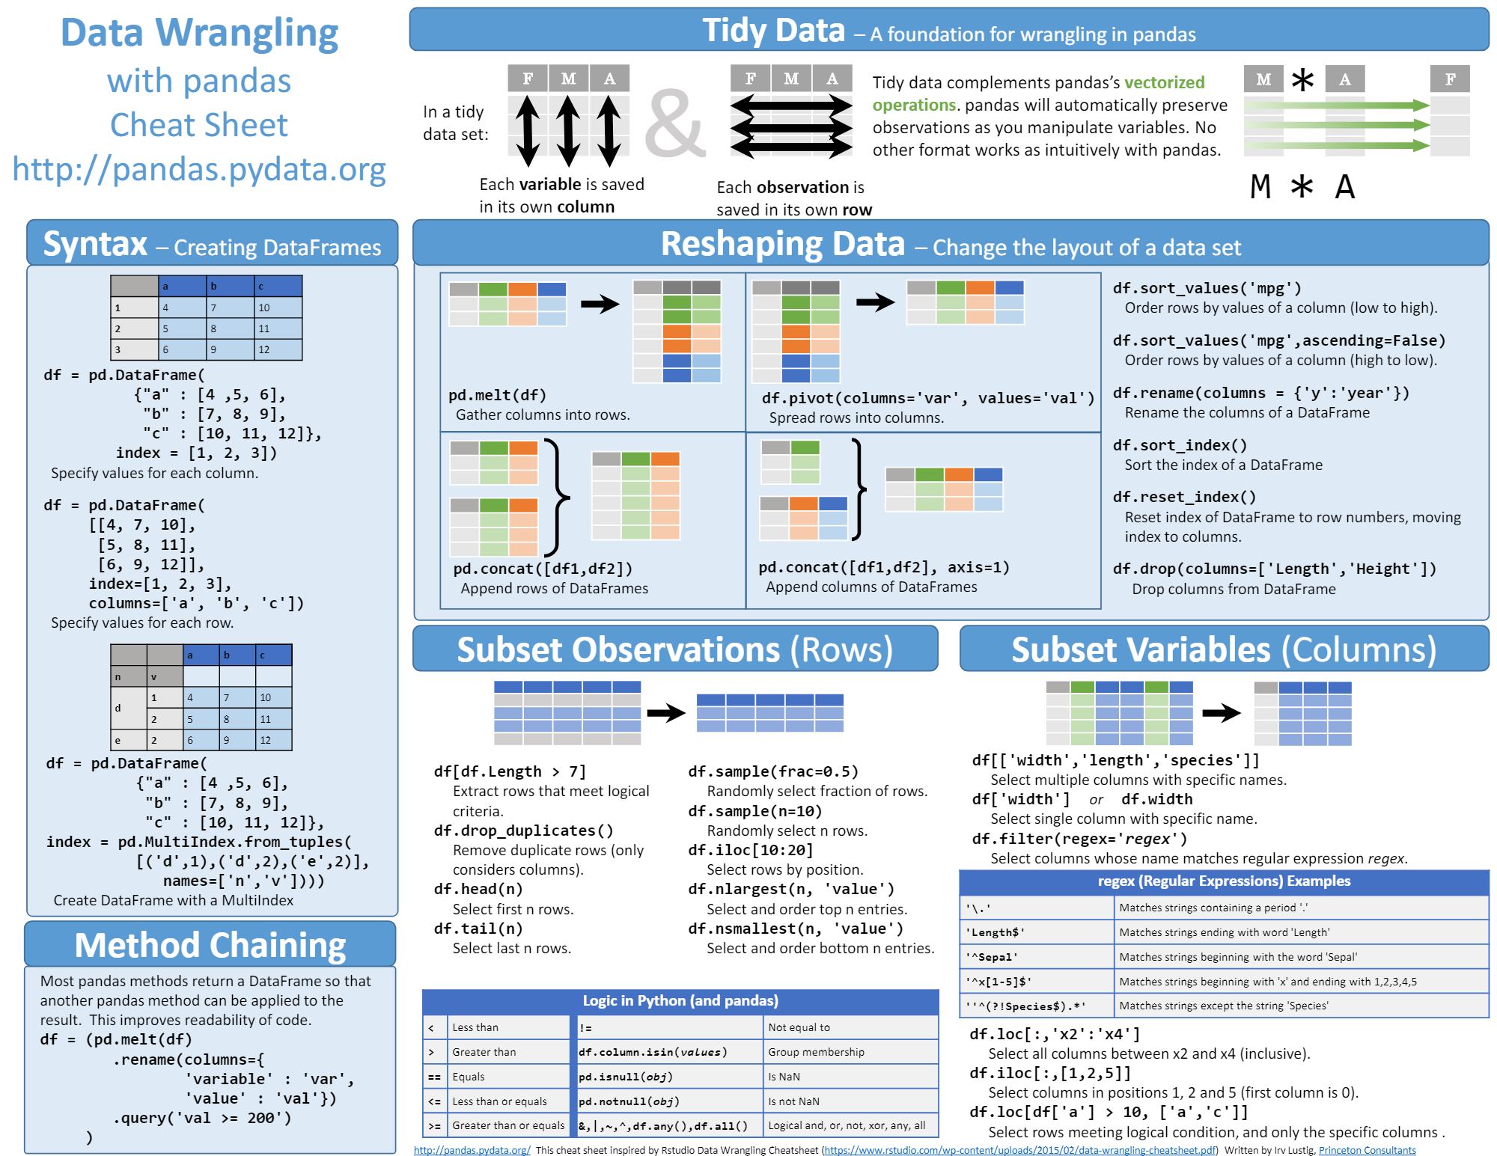

[Click to download](https://github.com/samadrita1/ML/blob/master/Pandas%20Sheetsheet.png)

Code snippet:

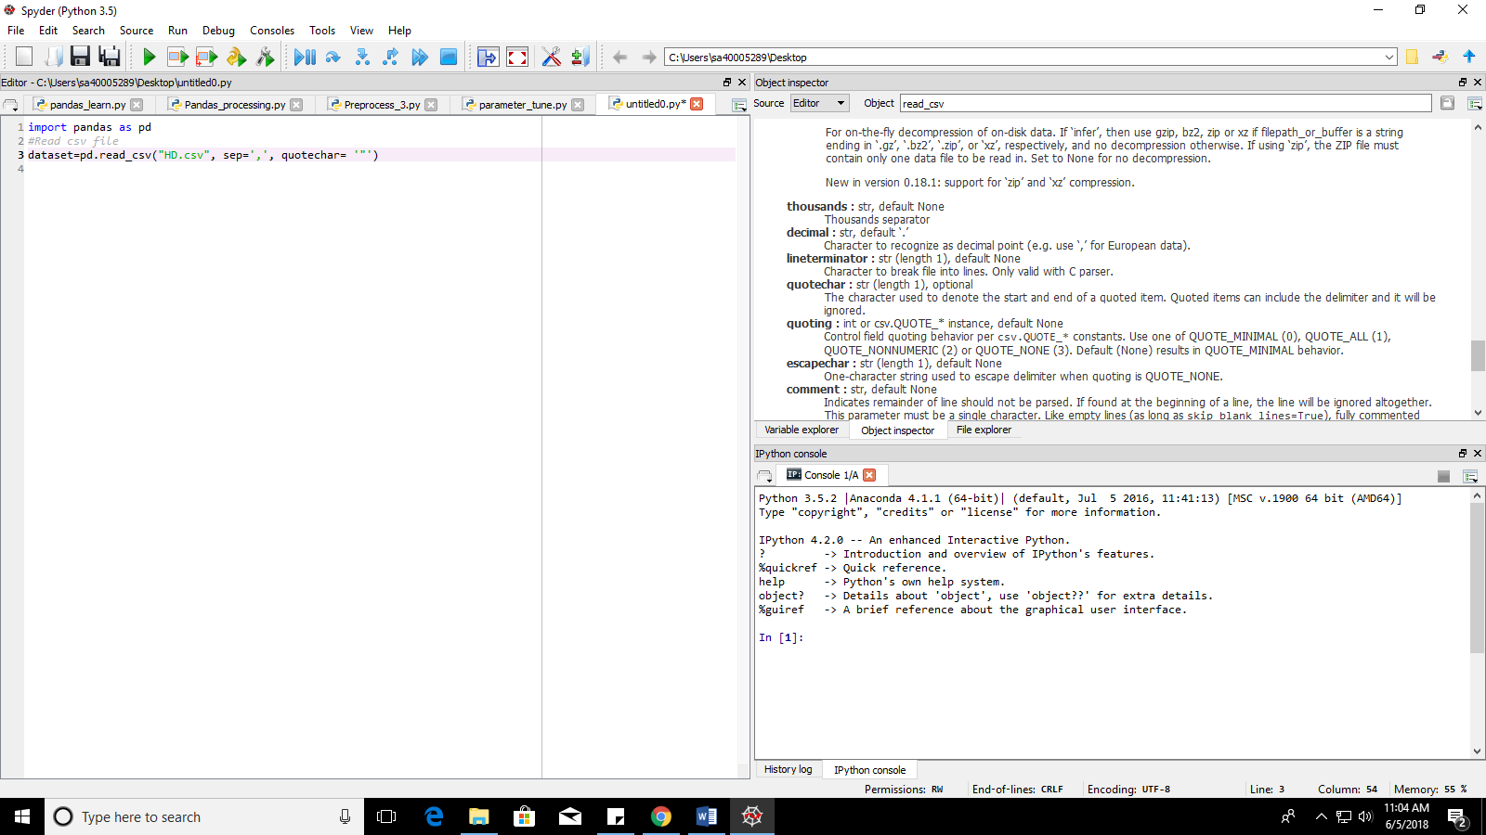

‘sep’ and ‘quotechar’ are important parameters.

‘sep’ helps the function identify the separator in a file. It is possible that attempt to read some files which are not in the csv format is made. In that case, the separator character needs to be updated accordingly.

‘quotechar’ helps to identify characters which are not to be interpreted as their default operation. Example, if we quote ‘,’, it will not be identified as a separator, but just as any ordinary string. This feature is useful when the dataset contains strings in form of sentences with punctuations and white characters.

[Click here for further details of csv_read function](http://pandas.pydata.org/pandas-docs/version/0.23/generated/pandas.read_csv.html)

1. Elimination of Columns not required.

Eliminated ‘Date’ column since a far more specific time range was available in the form of ‘hours of service’ under the ‘smart_raw_9’ column. Furthermore, the date varied insignificantly with respect to the target variable.

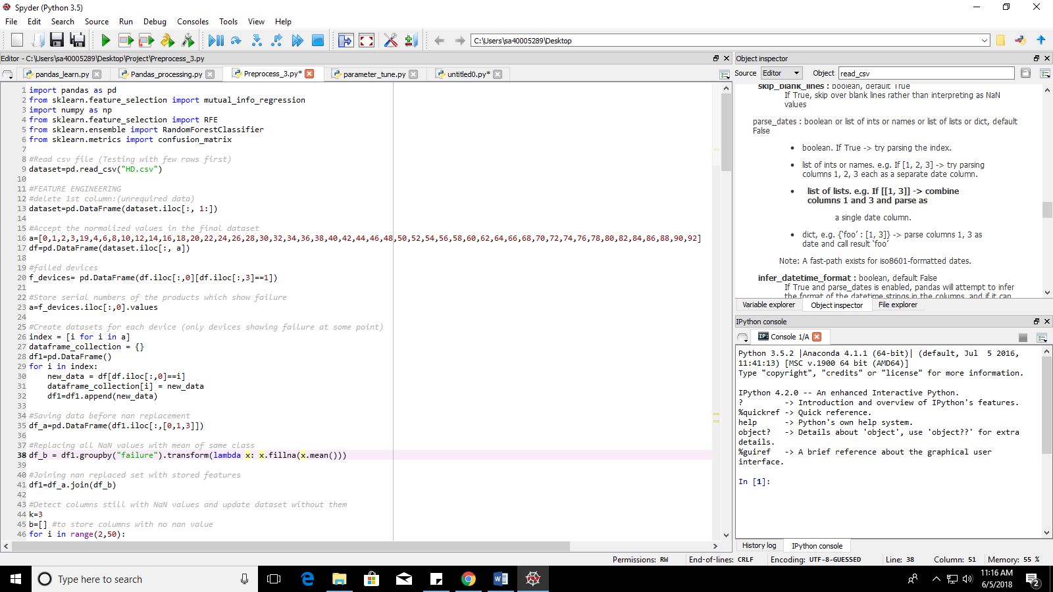

Columns with raw data eliminated since their corresponding normalized columns exist in the dataset. (Exception: ‘smart_raw_9’ column. It is kept to calculate ‘remaining user life’ later). Manual selection done since no specific range can be defined due to scattered normalized columns in the dataset.



1. Generate new dataset with instances of only the failing devices.

Procedure followed:

1. Store serial numbers of the rows which has value ‘1’ in the ‘failure’ column in a list.

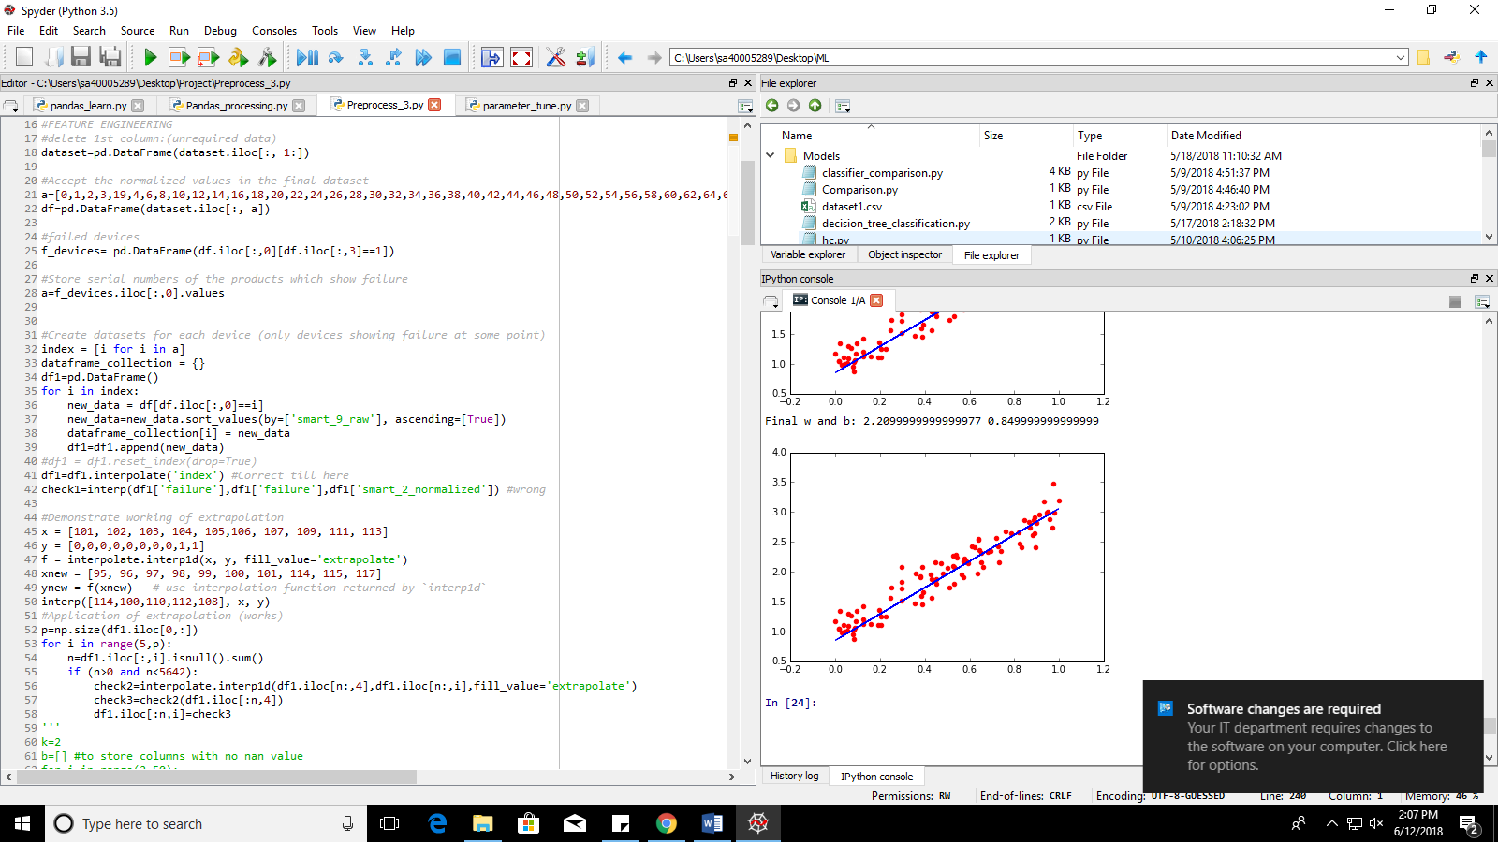

1. Use the stored values to track down all the rows with matching serial numbers
2. Create a new dataframe with the rows filtered out
3. Alongside, create a dictionary of dataframes where individual dataframes store data/rows of individual devices (serial_number). This is done to later extract values of the largest ‘time of service’ (in ‘smart_9_raw’) for every device. Also, it serves the purpose of checking if the code filtered the rows correctly.
4. The data in every dataframe in the dictionary is sorted such that ‘smart_9_raw’ is in ascending order (only for purpose of better understanding of the data by the programmer)



Devices which show failure stored in f_devices:

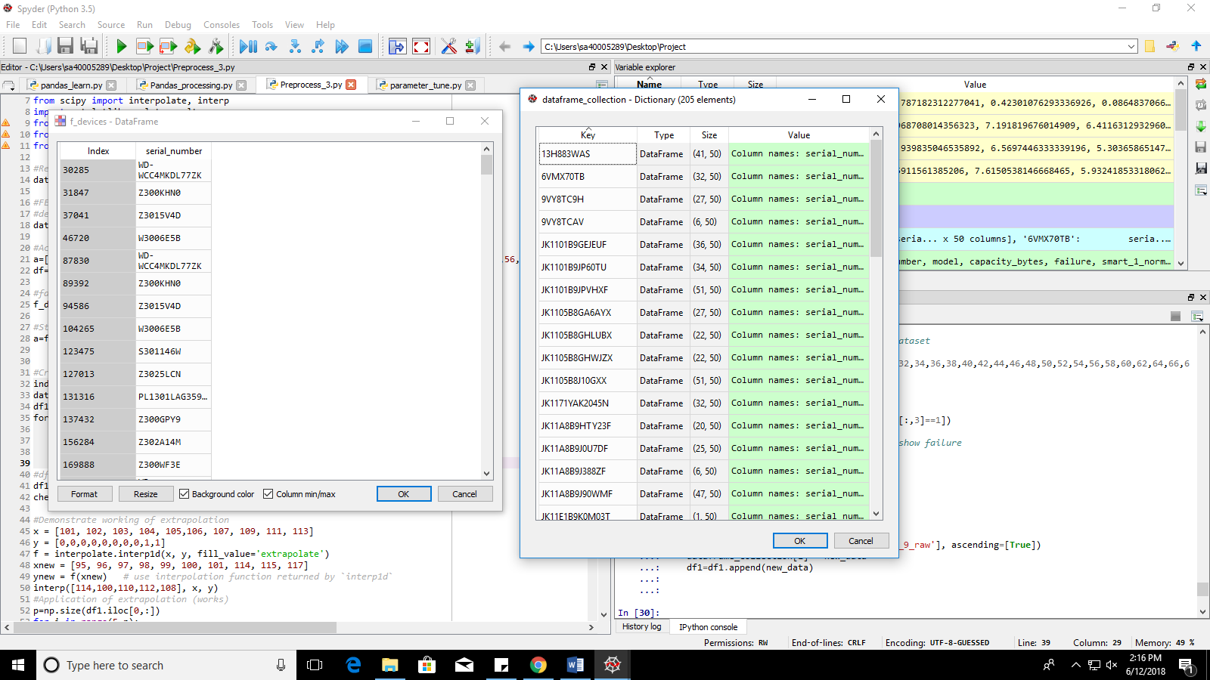

Dictionary of dataframes created:



New dataset with all instances of the failing devices (df1):

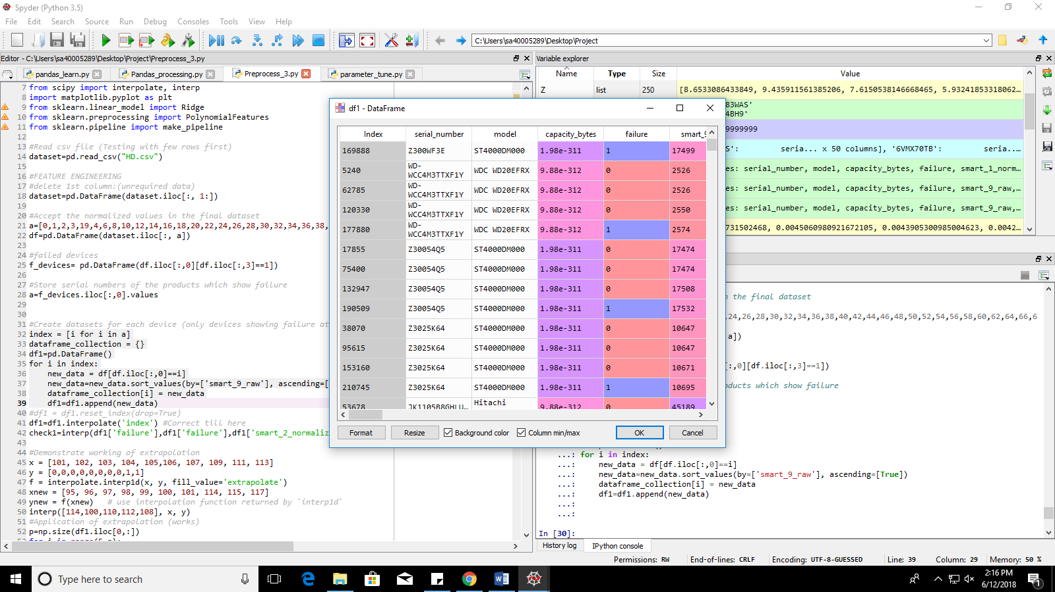

1. Removal of columns with all instances as ‘nan’:

Features with all nan values will be of no value when predicting results. This is because ‘nan’ essentially means ‘data not recorded’. If data is not recorded for any instance of the sensor, that sensor can be assumed as not useful.

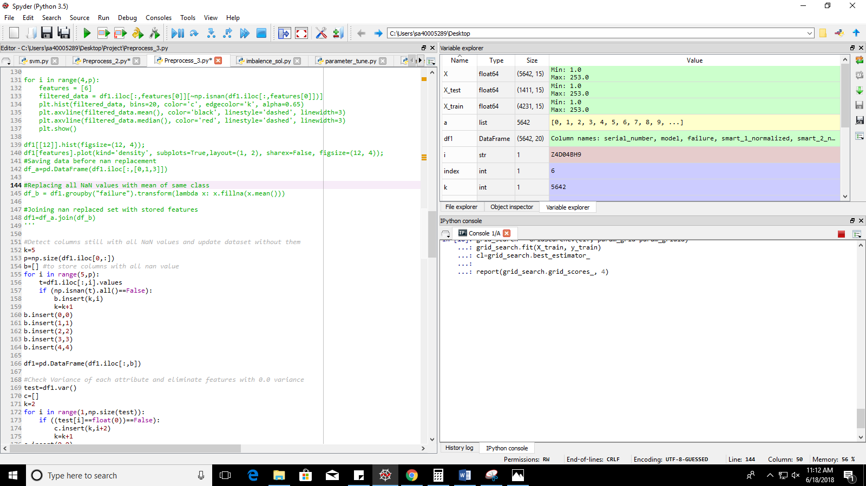

1. Removal of nan from the features:

Techniques used:

1. Replacement with 0 (integer or float representation of ‘zero’)

Discarded because: It is a misconception to consider nan as ‘0’, especially for the given dataset. Here the features are essentially sensor values. ‘nan’ means that the sensor did not report or take values for that particular instance/row. It is highly likely that value ‘0’ for a sensor may be considered as a weighted value (Example: Sensor may return value 0 when the device is failing, however that is not the case perhaps) Thus, we cannot replace the nan values with 0 since it will mean manipulation of data incorrectly.

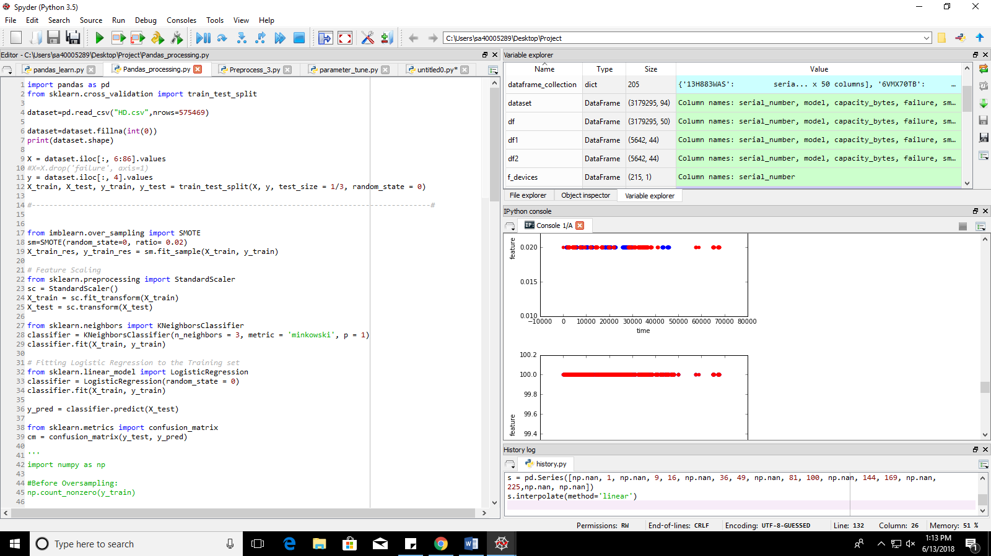

1. Replacement with mean of all rows of the respective feature

Discarded because: If we take mean of all rows for a given feature, the same value will be assigned to both the failing as well as working instances. However, in original data, sensors may give varying results for failing and working instances.

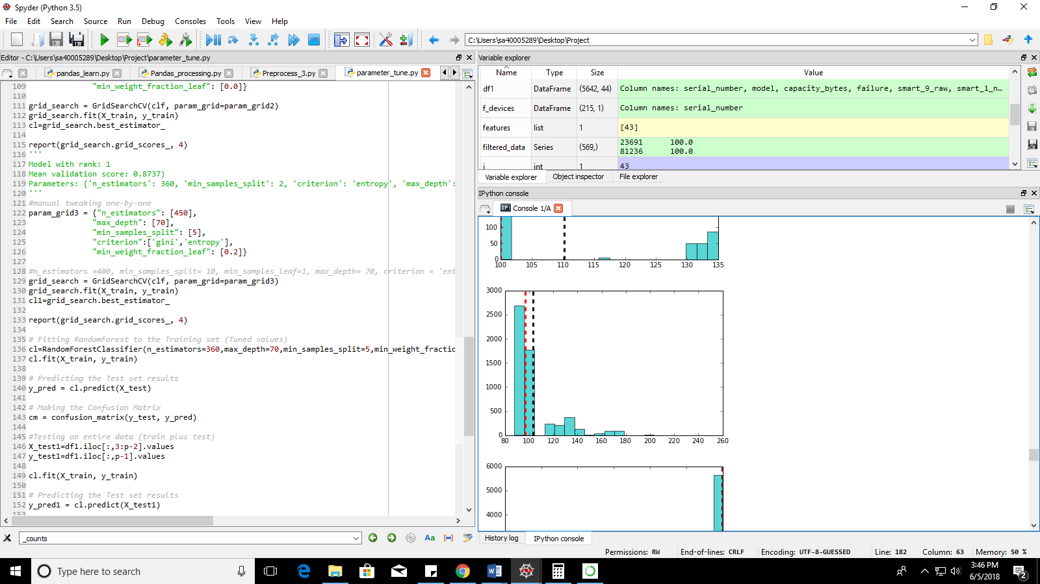

1. Replacement with mean of classes (0 or 1)

Discarded because: It may seem logically correct to assign mean of individual classes to the feature instances belonging to their respective class, since this method assigns different values for the failing and working instances/rows. However, if we visualize the data of the features along with their mean, for most of the features, the graphs obtained are either left skewed or right skewed. This means a good chunk of data is missing and the mean only takes into account the data available.



1. Replacement with median

Discarded because: Even though median gives better results compared to mean, it also suffers from the problem of missing data and only takes into account the data available, the problem of skewed data persisting.



1. Replacement with interpolated and extrapolated values

Accepted because: Interpolation helps us fill the gaps left by the missing sensor values. Interpolation takes into account the range of data available and varies the new data accordingly. This solves the problem of skewed data and partial replacements for nan. However, one problem persists. Interpolation cannot generate values outside the given range. Thus, features which has nan values at the beginning or at the end cannot be replaced with interpolation. Here, extrapolation comes into the picture. It effectively generates the necessary data required for nan replacement.

Interpolation: Helps to assign values as replacement to nan in features. Works only within given range. It needs a minimum and a maximum to determine the numbers in between them.

Extrapolation: When nan values exist outside the range of minimum and maximum, interpolation ceases to work. This is so because, if a limit is not present in the form of minima or maxima, interpolation cannot effectively determine the curve from one point to a non-existent one. Here, extrapolation takes the aid of another feature which has a well-defined relationship with the feature in question (determined with the help of mutual information), and predicts the values for replacement depending on the aiding feature.

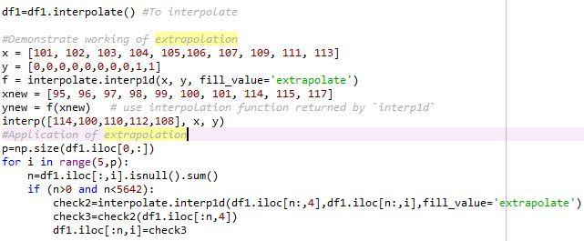

This code effectively eliminates all nan values if a feature has any. However, this is invalid for features which has all instances as ‘nan’.

1. Checking variance:

It is essential to understand that a feature which does not show much change in its instances/rows, is as good as a row with all ‘nan’ values. If there is no change in the feature, it is impossible to understand any pattern from it which might result in device failure. Thus, we check the variance and eliminate any feature which shows no variation (variance==0)

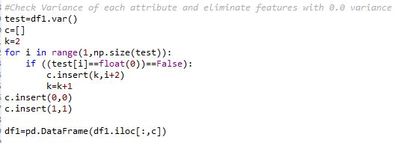

1. Checking relationship of feature with target variable:

Variation of feature is necessary, however if the variation is abrupt and with no clear pattern when mapped against the target variable, it cannot help us predict the target variable efficiently. To nullify this problem, we need to look for a relationship between the feature in question and the target variable. Techniques are mentioned as follows:

1. Correlation: Correlation captures linear relationships between the given features. It is in fact extremely efficient in tracking down linear relationships. However, it fails when strong non-linear relationships are processed. It might give a very low correlation value in spite of the presence of a very significant relationship among the data points.

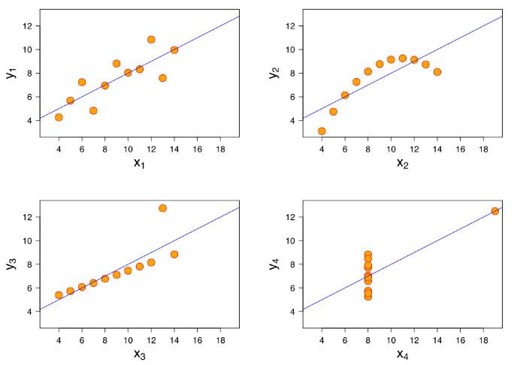

Reference Link: <https://towardsdatascience.com/why-how-and-when-to-apply-feature-selection-e9c69adfabf2>

1. Mutual Information: Mutual information solves the problem which arises due to correlation. Mutual information effectively captures any non-linear relationship between the given variables. This helps us to eliminate the features which show no significant relationship with the target variable, which helps us strengthen the predictive model which is to be constructed. It is essentially a measure of the how well a feature can be determined from another feature which is known (/with respect to another known feature).

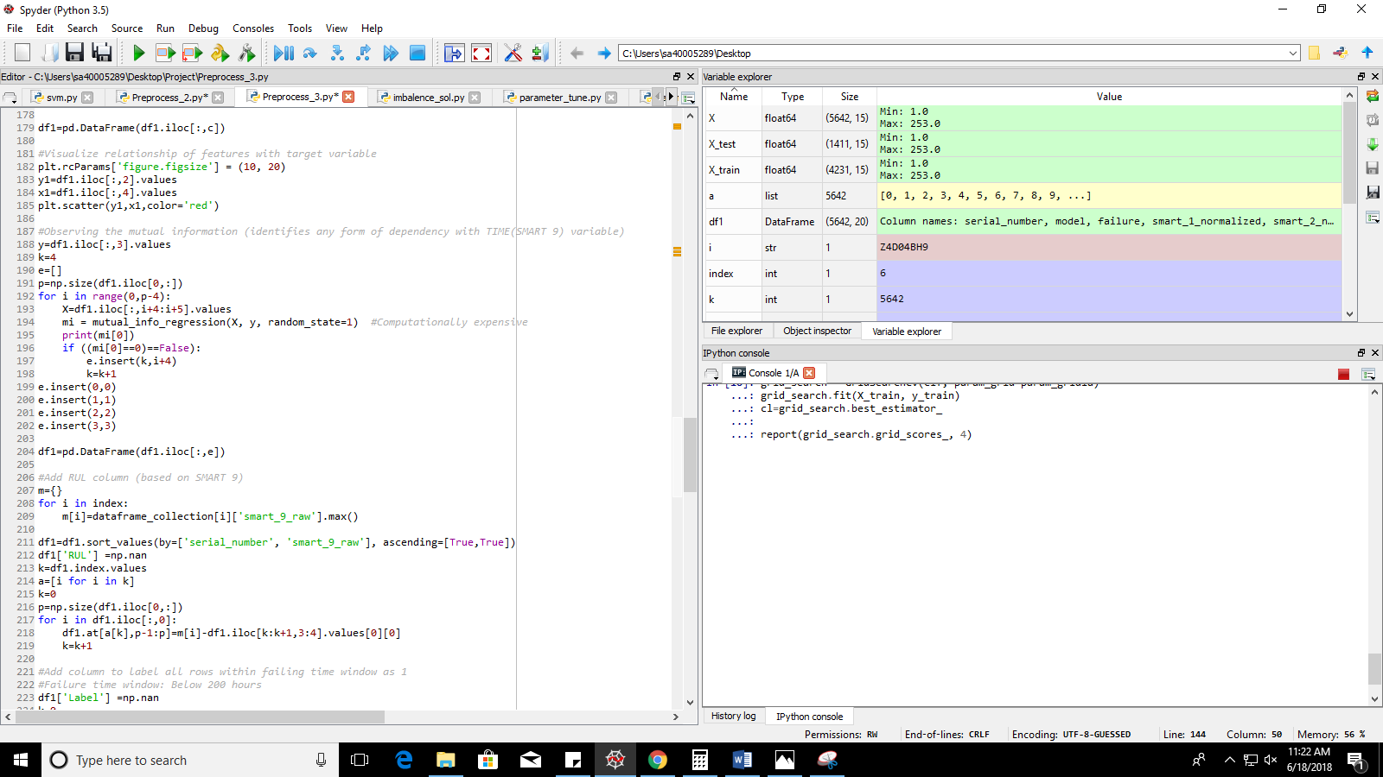

For mathematical knowledge: <https://en.wikipedia.org/wiki/Mutual_information#Definition>

1. Create column for Remaining Useful Life: ‘RUL’

The current dataset in our hands contains a feature ‘smart_9_raw’ which stores the number of hours it has served. Since all the devices in the present dataset are failing devices, we can find out the remaining life for the device at a given time (at a given instance). This can be done by spotting the maximum time a particular device has served, and then by subtracting the hours of service in every instance from the maximum time served.

Example: If a failing device has an instance which shows that it has served for 3 hours. That instance has records of all the sensor values at that particular moment (three hours after starting the device). Now after checking all devices, we look for the maximum hours served at ‘failure’==1. This gives us number of hours served before the device fails (say, 10 hours). Now, we can derive the remaining user life for the instance with 3 hours served by subtracting 3 hours from the maximum time served. (10-3=7). Remaining user life of that particular instance is therefore 7 hours.

Implementation: This entire process is carried out with the help of the dictionary creating during sorting out the failed devices (page 17). The dictionary which was created is a collection of dataframes of individual failing devices. Each dataframe stores instances of only one particular device. Thus, from the dictionary, we pick a particular device, find its maximum, and use that maximum to find ‘RUL’ for all the instances in our current dataset. In the code, a new dictionary ‘m’ is created which stores serial_number as keys and the maximum time served as the values.

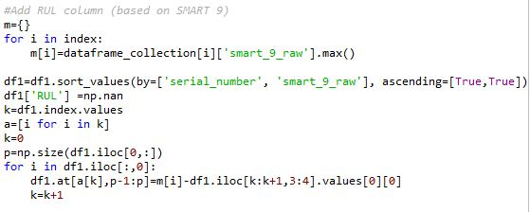

1. Create column for labels: ‘Label’

After the ‘RUL’ column has been constructed, we need to decide the time window within which a warning alarm must be activated. In simple words, we need to set a limit of number of days before device failure, when the user will be notified about the failure looming in the future. For this particular model, the number of days has been set at 10, or 240 hours. Thus, any device instance which has remaining user life below or equal to 240 hours, will be assigned label 1. (Label 1 indicates that the alarm is activated). All other instances are assigned label 0 (label 0 indicates that the alarm is not activated).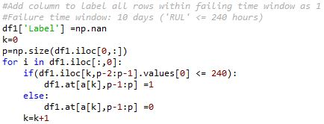

The column ‘Label’ now becomes the new target variable which the model must predict. (Since it is not our job to determine the exact failing instance, but to predict failure ten days before actual failure)

1. Feature Selection/Elimination

Even after extensive preprocessing, we may still be left with a large number of features. If we feed all the features, which are not very well related with either the target variable or with each other, our model will become computationally extensive and carry unnecessary burden of the redundant and distantly related features. This problem is solved with the feature selection/elimination techniques which helps us track down the best ‘n’ features for the model in question (where n is the number of features). Techniques:

1. Univariate selection: Not used since it checks relatability of target variable with individual features and this is not an optimum way to get best model for the dataset. (Since model works on a collective set of features and not individual feature)
2. Principal component selection (PCA): PCA transforms the dataset into a compressed form with the aid of reduction techniques. It then ranks the features depending on the compressed form of the original data. This is not useful for our dataset since we want to analyze the best features on the original form.
3. Recursive Feature Selection

There are further techniques to select features. Overview study can be found here:

<https://machinelearningmastery.com/feature-selection-machine-learning-python/>

<http://fatihsarigoz.com/tag/machine_learning-feature_selection-rfe.html#4.-Feature-Selection-via-RFE>

Recursive Feature Selection has been selected for the dataset in question here. It eliminates one feature at a time (default: 1, other values can also be fed as parameter), and construct the decided model with the remaining features. With the help of the accuracy of the model constructed (for a series of tries), it decides which feature to eliminate. The process is continued until the top ‘n’ features are ranked as ‘1’. Then we update the dataset by eliminating all other features with rank not equal to 1.

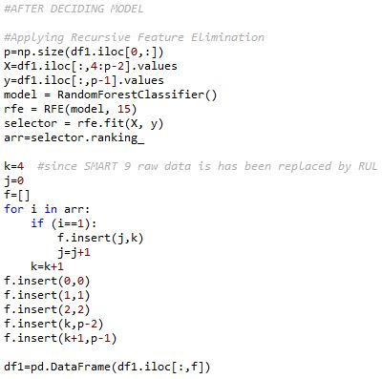

Here, RFE has been constructed with respect to Random Forest Classifier.

1. Splitting data into testing and training sets

The dataset we have at hand must be separated into two parts such that the model uses one part to learn and process the patterns, and uses the other part to test its learning.

The training set must at least be greater than or equal to 50% of the entire dataset. This is because the model will require a sufficient set of data to understand and learn the recurring patterns. In general, 80% of the dataset is used for training purpose.

The test set is used as a judgement tool for the model. The values predicted by the model is compared against the original values in the test set. If the performance metrics are promising, the model can be classified as useful, otherwise, it is necessary to remodel the learning techniques. In general, 20% of the dataset is used for test purpose.

Implementation: In the project, train_test_split() of scikit learn has been used to do the same. It helps to split the dataset accordingly. The division of instances into training and testing datasets is often random (based on the seed specified in ‘random_state’).

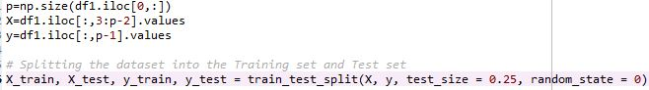

1. Other preprocessing modules

There are many other preprocessing functions, which have not been used in the project mostly because the dataset used did not require the application of those functions. Some of the most important and popular modules of preprocessing are Feature Scaling and Label Encoding.

Feature Scaling helps us scale all the features in the dataset with respect to each other. In simple words, it means that it helps us normalize the data. Since we already had normalized data in our feed, we did not require this module in our code.

More information:

<http://scikit-learn.org/stable/auto_examples/preprocessing/plot_scaling_importance.html>

Label Encoding helps us convert features of type string or character into suitable numbers or combination of numbers. Simple label encoding maps a string value to a number. One Hot Encoder helps to map a string value to a combination of numbers, with each number in separate columns (0s and 1s), such that no particular string gets a biased treatment just because it has been mapped to a higher number through simple label encoding. In our project, the only string feature which needed encoding was the model number. However, we had 60 separate models. If we used simple label encoder, we would have faced a bias for the higher and lower numbers the models have been mapped to. And if we used One Hot Encoder, we would have got (60-1=) 59 new columns which would have increased complexity for the model.

More information:

Label Encoder: <http://scikit-learn.org/stable/modules/generated/sklearn.preprocessing.LabelEncoder.html>

One Hot Encoder: <http://scikit-learn.org/stable/modules/generated/sklearn.preprocessing.OneHotEncoder.html>

1. Feature Selection: Modified Method (Iterative Feature Elimination/IFE; Criteria: Recall)

As mentioned in point ‘10’, Recursive Feature Elimination (RFE) was used to select best ‘n’ features from the dataset. However, when further experiments were conducted with different classifiers, it was found that RFE works only for a selected number of model implementations in scikit learn. These are the models which return a set of coefficients and feature importance for every feature, which are in turn used by the RFE code to interpret the best features recursively. However, as is sometimes suggested, RFE is not always very accurate when it comes to feature selection. For in depth knowledge, one needs to understand how the feature importance is determined. As far as was grasped in the overview of the functioning, its understood that feature importance depends on the error determined by the respective loss function in a model. If with removal or addition of a feature, error reduces or increases by an insignificant amount, that feature is considered to be less importance (and vice versa).

Since our model’s primary goal is to maintain high Recall/Sensitivity, error in terms of false positive (Success classified as failure) is not much of our significance. Instead our focus must be on the error introduced by misclassification of failures as success cases. Thus, a new method is devised to select features based on the criteria of sensitivity and not feature importance and coefficients (weights added to the features). Furthermore, in RFE, we do not know the exact number of features which need to be selected to provide the best subset to our model. IFE overcomes this problem with ease. It selects the exact number of features which gives the best result.

On experimentation, it has been found that this method works with extreme efficiency as far as our model is concerned since it is sensitive to true failures.

Code Snippet:

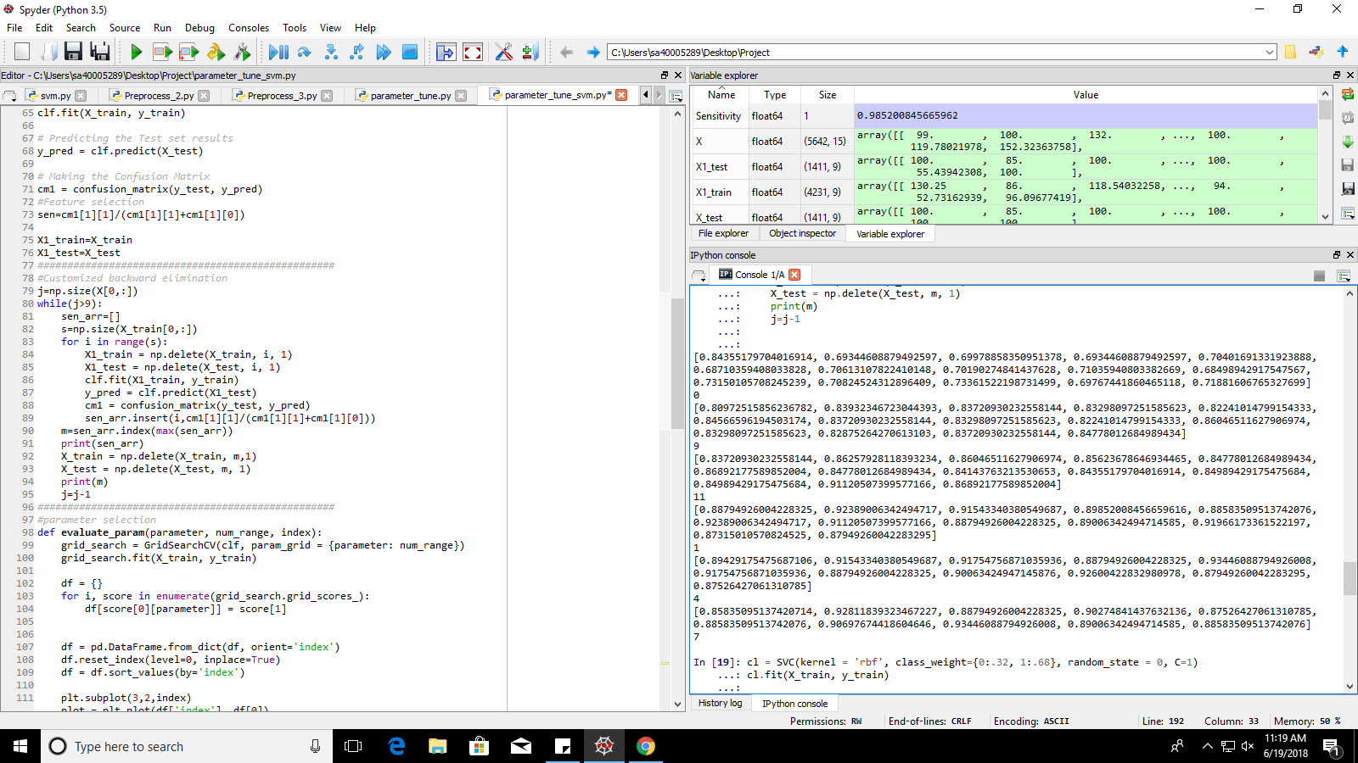Method:

1. One feature is eliminated at a time, and with each elimination, sensitivity is checked.
2. If there are 10 features, in first iteration, a loop will run for ten times where one feature will be eliminated at a time, and sensitivity will be calculated on the remaining 9 features. The set of 10 sensitivity values will be stored in list sen_arr[].
3. ‘m’ will store the index of the maximum sensitivity value.
4. Then the feature which corresponds to that index will be eliminated.
5. This method will be continued until a drop in maximum recall is found in two consecutive lists (figure below). The underlined line is the maximum the recall reaches in all the iterations. At this point the coder has to re-add all the features that were deleted even after the maximum sensitivity is reached (the arrows demonstrate decreasing values downwards). If max recall remains unchanged compared to max recall of prior list, eliminate the feature (minimum features with same sensitivity will reduce computational expense)

Lists (sen_arr) for every iteration:

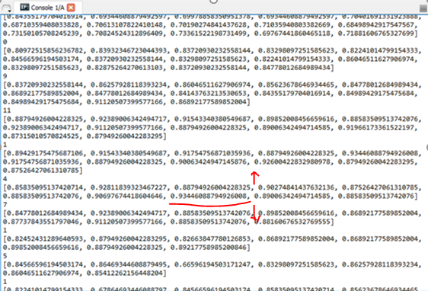

Features selected through Recursive Feature elimination:



Features selected through Iterative Feature Elimination (Criteria: Sensitivity)

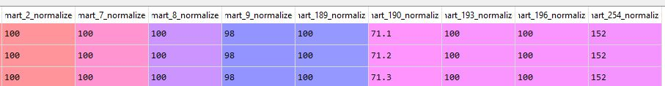

This method was implemented first on SVM classifier, since no other concrete method of feature elimination was found at the moment for SVM. (SVC in scikit library does not generate feature importance or coefficients, thus RFE cannot be applied). Results are as follows:

Results with and no feature elimination or parameter tuning:

**Sensitivity of 71%**

**Accuracy of 87.6%**

**Precision of 89.6%**

Results after Parameter Tuning and no Feature Elimination:

**Sensitivity of 91.9%**

**Accuracy of 89.7%**

**Precision of 80%**

Results after Parameter Tuning and Feature Elimination:

**Sensitivity of 98.5%**

**Accuracy of 91.42%**

**Precision of 80.34%**

An Experiment was conducted to check which elimination technique gave better results (RFE or IFE). The procedure of experimentation has been explained under:

* First the RFE features were used to find the performance measures with Random Forest Model. (Along with parameter tuning: previously applied)

Results:

Sensitivity: 93.7%

Accuracy: 96%

Precision: 95.5%

* Next, the features obtained from IFE with SVC code were used to check the performance measures with Random Forest Classifier. This is done to check if almost the same features get selected for both the models.

Results:

Sensitivity: 96.1% (preferable)

Accuracy: 96.4%

Precision: 93.4%

* After that, IFE was used with Random Forest to eliminate features.

Results:

Sensitivity: 96.4% (preferable)

Accuracy: 96.5%

Precision: 93.6%

Found that the feature sets selected with IFE differs when the model is changed. However, if we take the same features for both models, the difference in performance measures, as observed, is almost insignificant.

Thus, we can conclude that IFE is a much better suited algorithm for feature selection for our particular problem. We can also say that some features in the dataset are essentially important, irrespective of the classifiers used, since the same subset of features give almost similar results for different classifiers.

Code after automation: ‘g’ variable holds max recall value.

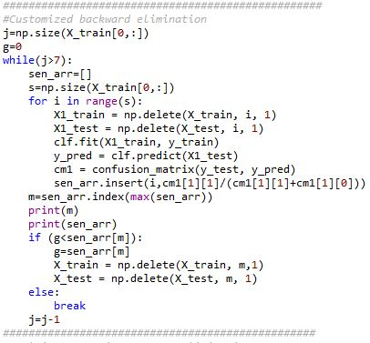

3. Model Selection and Parameter Tuning

3.a Parameter Tuning

Before we jump into training Models, we need to know ways through which we can control the behavior of the model to a certain extent. Models are prototypes created by brilliant minds in the past. It is a coders duty to feed the model with a good feed to facilitate good performance. “A car without fuel is as good as a showpiece”.

In this project, parameter tuning have been implemented with both automated and manual modifications. The algorithm used for parameter tuning in this project is GridSearchCV. If we have too many parameters to tune, grid search may become unfeasible. That's when random search must be used. Random Search tracks down the top subset of parameters from the entire parameter set provided, within only a few iterations. Thus, for large datasets and models with a high number of hyper parameters, Random Search is an optimum choice. It effectively helps to spot the near-best and sometimes best set of hyper parameters. In the present day, Random Search is preferred over Grid Search in 90% of the real-world-data processing problems.

Read more here: [Why is Random Search better than Grid Search?](https://analyticsindiamag.com/why-is-random-search-better-than-grid-search-for-machine-learning/)

On the other hand, Grid Search is robust, exhaustive and uses Brute Force to select the subset of hyper parameters. However, its drawback is that it is quite slow since it iterates through every combination possible in the grid, and even with such exhaustive execution, the best result may not be found. This is because Grid Search does not take into consideration the order of importance of the parameters, leading to a possible bias in the output.

In this project, Grid Search was implemented in all the codes at a certain point of time. I came across the benefits of Random Search at a much later stage, leaving me very little time to implement it in the set of codes. It is suggested that the Random Search algorithm is used if the code needs to be modified in the near future. It will improve both time complexity and results.

Implementation:

When grid search is applied on combinations of parameters in the grid, it generates a set of scores (mean validation score). This score is used by our code to plot graphs of mean validation score against index number for every parameter in the grid.

Parameter Tuning with Grid Search

Grid Search is an algorithm which helps us tune the parameters to obtain as good results as possible. It does not always guarantee the best results, as already mentioned. It is essentially a brute force technique to check every combination of the range of hyper parameters provided to the grid dictionary. As is obvious, grid search takes a lot of time to find the optimum set of hyper parameters for our model. Even more so, if the predicting algorithm is computationally expensive. The method of Grid Search has been demonstrated as under for the Random Forest Algorithm:

These are the range of possible hyper parameters which are provided to a dictionary. The range is decided by taking a random guess, and it is made sure that enough samples are included in that range. The dictionary is thereafter passed as a parameter to the grid search function call.

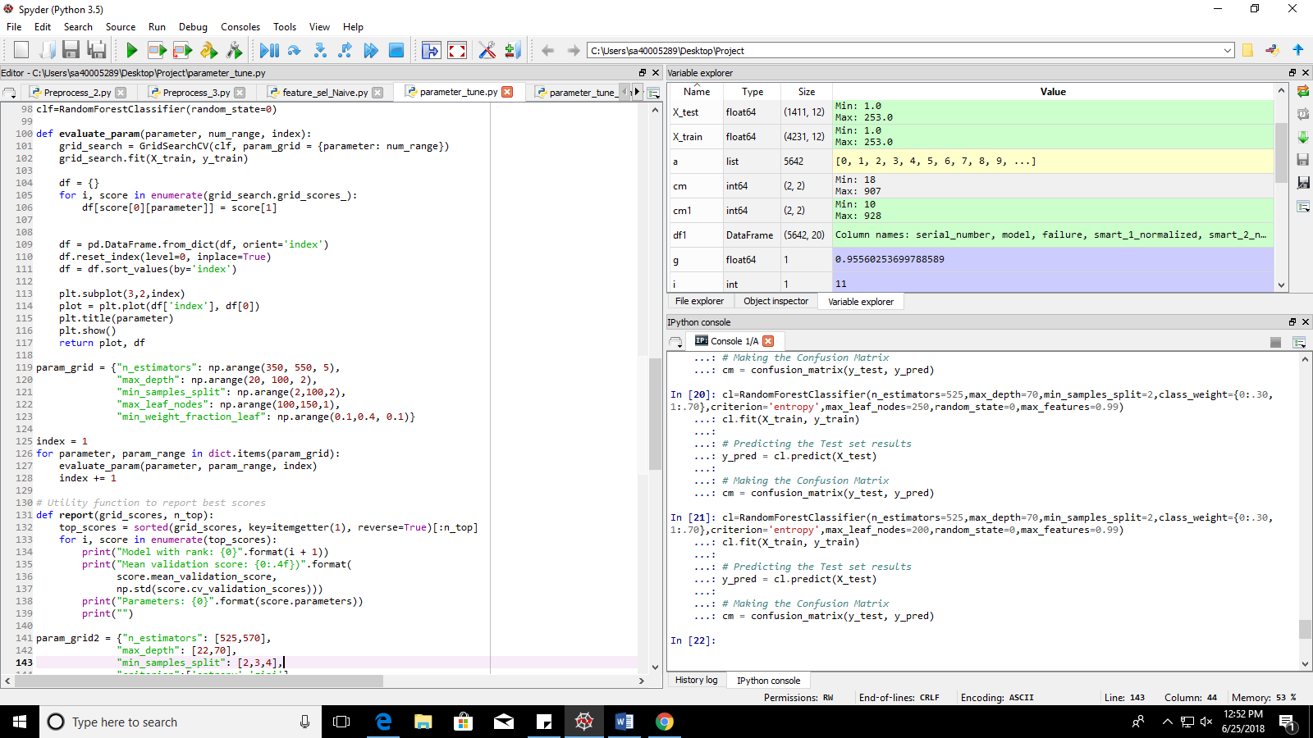

The function defined below (evaluate_param) is used to visualize the plot of range of parameters against the [cross validation score](https://en.wikipedia.org/wiki/Cross-validation_(statistics)). We use this visualization technique so that we can narrow down the range of the hyper parameters depending on the peaks in the visual data that we observe. We need to narrow down the possibilities since then with the narrowed down range we can run a grid search again to get more accurate results. Also, manual tweaking can be initiated to a certain degree in the second loop. This method can be automated, but altering the range manually is way more simple and also helps the designer to introduce certain manual feedback with his device which the automated algorithm may not be able to provide.

On running the code below with our decided range, we get a graph for every hyper parameter. The peaks in these graphs are where the performance or the validation score will turn out to be its best. There can be more than one peaks, which leads us to the second loop.



These are the graph plots obtained after running the above code:

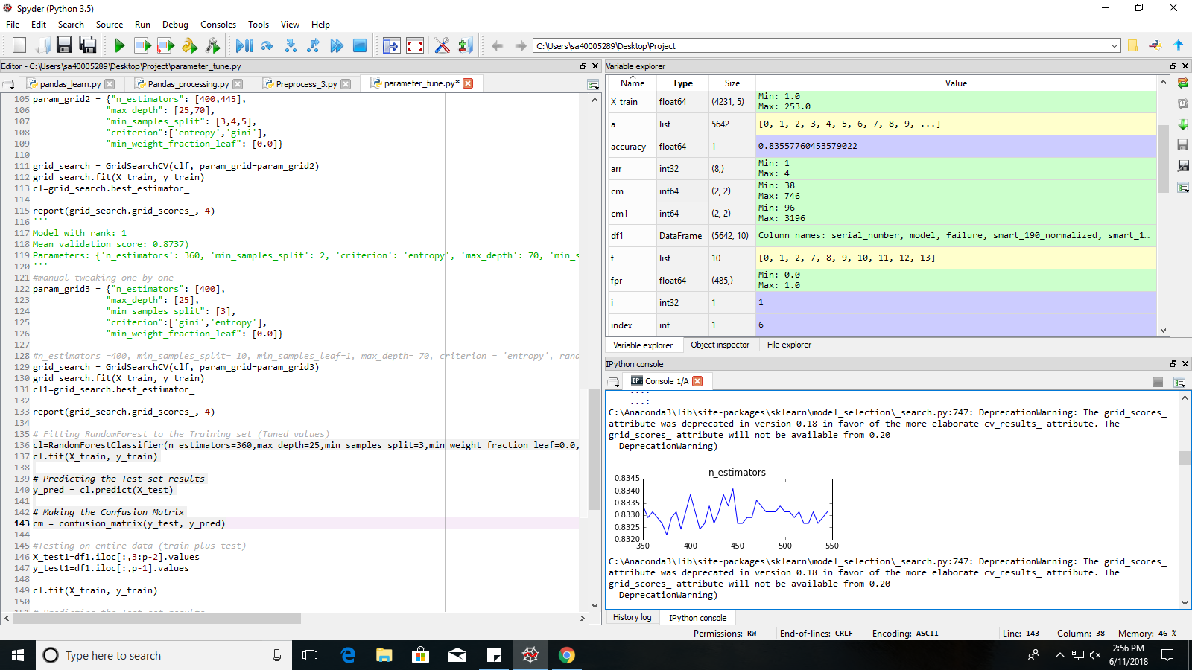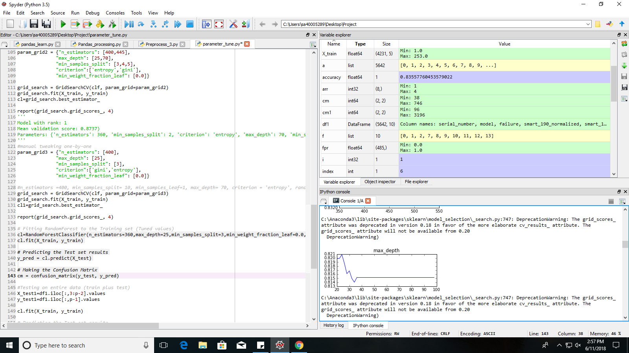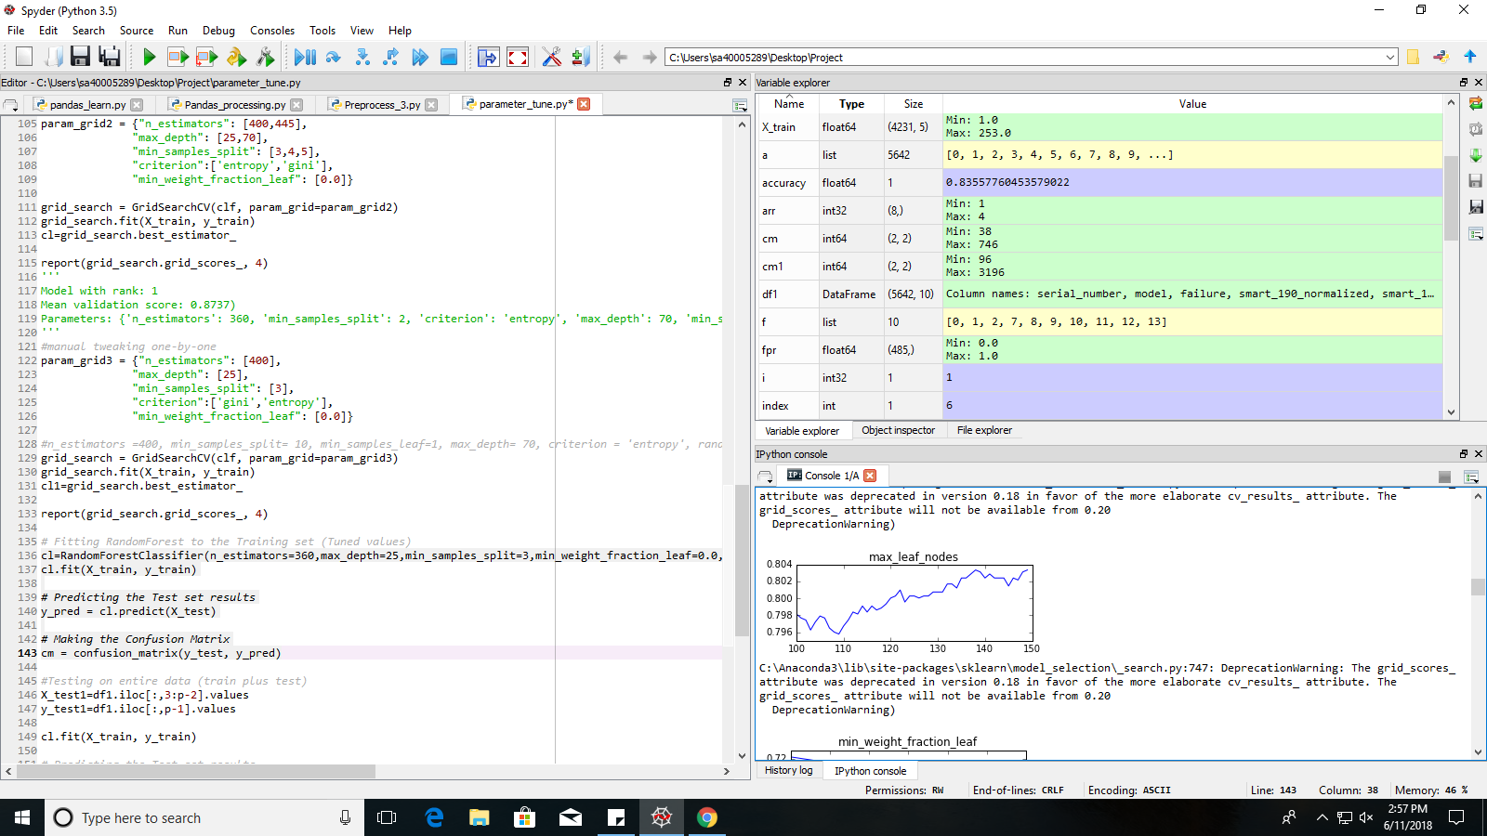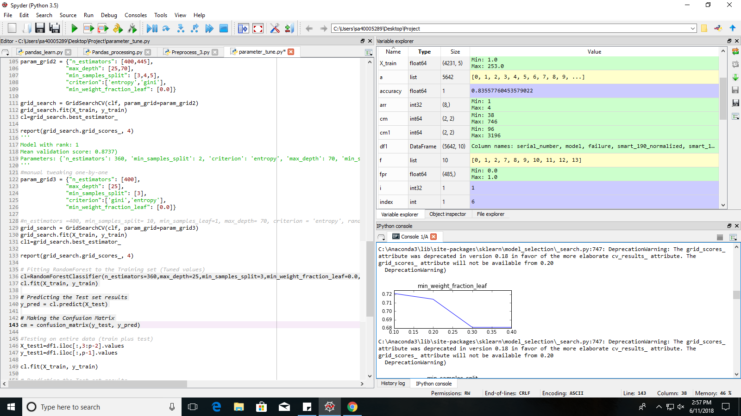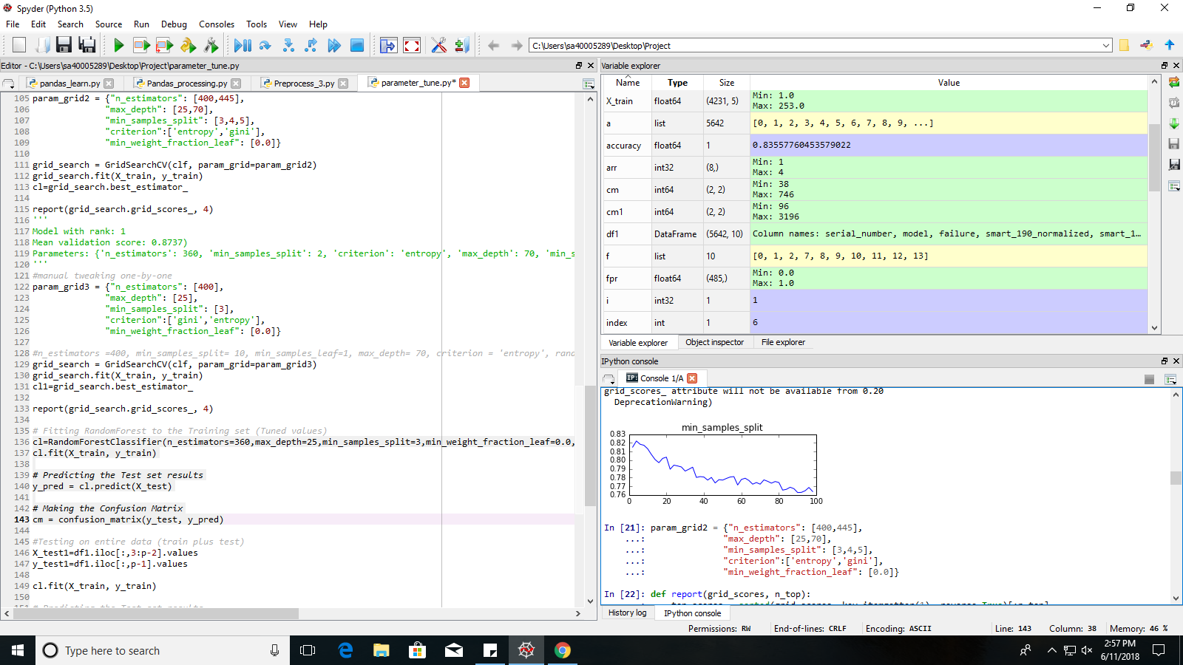

After observing the plots, we take the range such that it included the value which results in the peak (or peaks). Second grid:

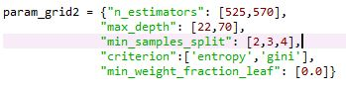

As one will notice, the range has been narrowed down to a great extent keeping only the peaks (and sometimes a few values around it. Now, we use this dictionary to obtain the top four combinations based on their highest mean validation scores. The following function is used to do the same:

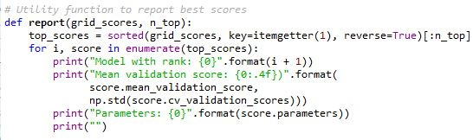

This effectively provides the combinations it thinks are fit to be applied for a good result. The designer may choose to run another loop for more precise results, but it is seldom not necessary with few parameters and a limited number of peaks. (In this case, I have used an extra loop and called the same “report” function).

3.b MODEL SELECTION

3.b.1 Naïve Bayes

Model Intuition: Naive_Bayes (Ctrl+Click to move to required page)

Insight: Naïve Bayes, as the name suggests, has a naïve approach towards data prediction. For any dataset it processes, it assumes that the features in the dataset are independent of each other. This is most often not true when real world datasets are concerned.

Also, Naïve Bayes, due to very limited parameters, is a self-relying algorithm and does not cooperate much if programmers desire to tweak or modify its behavior. This makes interpretation of imbalanced data more challenging.

However Naïve Bayes may work well for inter dependent features as well if the dependence cancels out in the dataset overall or the inter-dependence is not that strong.

For our dataset, the Naïve Bayes approach is discouraged due to the limited parameter modifications possible. We cannot modify the model enough to meet our demand of high sensitivity (minimum false negatives: 1/failure misclassified as 0/success).

There are three Naïve Bayes algorithms, 2 of which have been tested for our dataset.

1. Gaussian Naïve Bayes:

This algorithm performs best if our features have a Gaussian or near-Gaussian distribution. This means that our features must be devoid of outliers as much as possible for optimum results. On application of GaussianNB() to our dataset, we obtained substandard results.

After the newly devised Iterative Feature Selection which is biased towards Sensitivity, we could only improve the sensitivity from **~15% to ~30%**, which indeed is a very poor model.

1. Multinomial Naïve Bayes:

This algorithm is used when the features consist of discrete values (Example: Height). The distribution can be continuous (Example: Increasing order of Heights).

“When a feature is discrete but not binary (or continuous but approximated by such discrete values) a common choice of likelihood is the multinomial distribution, hence Multinomial Naive Bayes. This is a direct generalization of the Binomial Naive Bayes model.”-Quora: Michael Betancourt, PhD in Physics with focus on Data Analysis, MIT.

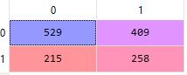 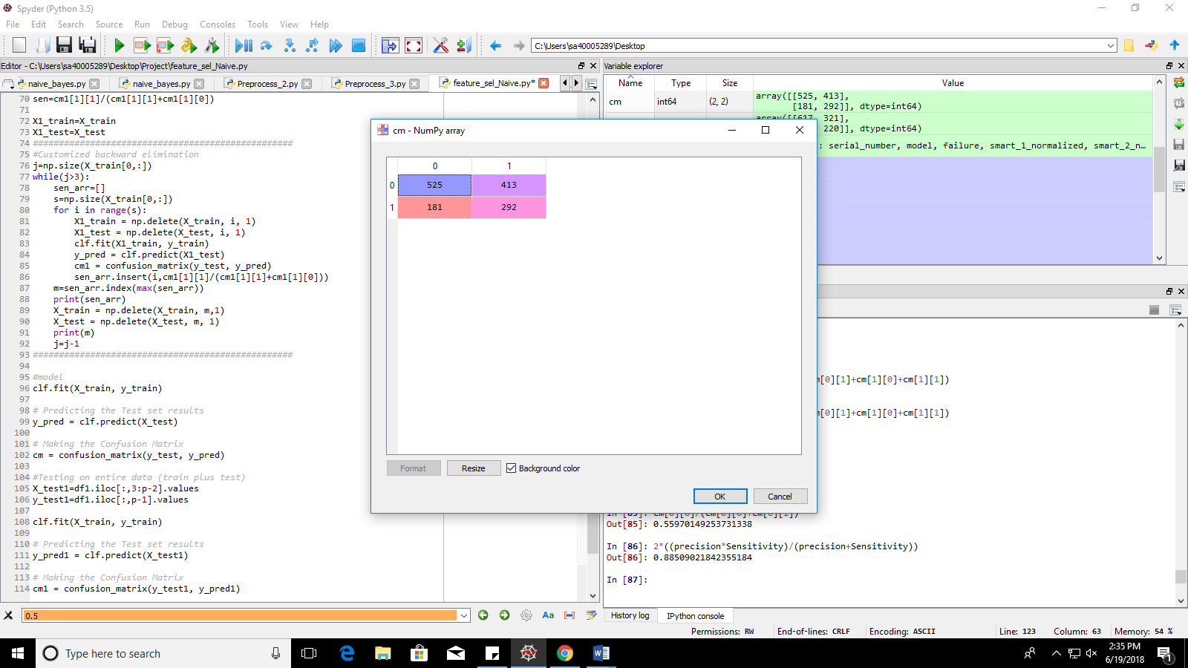

Initial Sensitivity: **~54%**

Final Sensitivity: **~62%** (After application of Iterative Feature Selection)

The results have improved significantly on application of Multinomial Naïve Bayes when compared to implementation of Gaussian Naïve Bayes. Thus, overall improvement among the two algorithms is **30% to 62%**.

This might seem like a promising improvement, but the result is not good enough if we can predict failure only 62% of the times. With this Sensitivity rate, the model cannot be relied upon practically. Thus, we will shift to another classifier.

3.b.2 Random Forest Classifier

Model Overview and Intuition: Random_Forest

Insight: Random forest (RF) is a predictive model and not a descriptive model. Thus, this is used mostly when our model needs high performance but not much interpretability. We can obtain good predictions of the target variable from the features but it is mostly difficult for the algorithm to demonstrate a relationship between the features and the target variable to the user.

Also, Random forest is inefficient for small datasets since in that case, it cannot create enough varying subsets for individual decision trees. However, since this dataset is sufficiently large, we can provide the algorithm with sets of rows/samples or features without exhausting the data or providing extremely redundant data to every tree in the forest.

Random forest works well with missing data as well. As observed from visualization, it has been noticed that our dataset has missing values which we have tried to overcome with the aid of interpolation and extrapolation. Since RF works extensively on subsets it can provide very good performance even if some values are missing or have been interpolated poorly.

The most significant disadvantage of RF are restricted to high computational expense and lack of interpretability. But fortunately for our dataset we do not need interpretability.

Random forest has several parameters which we can manipulate as required to obtain better results. Few of its hyper parameters which have been modified to obtain the best performance are explained as follows:

n_estimators: The value of n_estimators signifies the number of decision trees in the “forest”. Every decision tree is provided with a set of samples and features to arrive at an “opinion” (Example: yes or no/1 or 0) regarding the target variable. It follows “the more, the merrier” custom. Every decision tree provides a result by arriving at the result from scratch. The Random Forest accumulates the decisions of every decision tree in the forest and arrives at a decision on the basis of a “majority”. More trees help to overcome the problem of overfitting just like a larger number of voters leads to a far less biased choice of candidate in an election.

max_depth: This represents the depth of every decision tree, which is for how long the decision tree must continue to split and capture further information.

min_samples_split: this decides the number of samples required for spitting an internal node. We need to maintain a low value for this since a high value will restrict the tree to choose a lot of samples and thus, narrow down the possibilities of varying samples for different trees in the forest.

max_features: It tells us the maximum number of features to consider while looking for an optimum split.

max_leaf_nodes: It defines the maximum number of leaf nodes that can be permitted in a tree. Pruned in best first order.

criterion: It helps a user to specify which type of error measurement or “impurity measure” technique they will prefer. There are two options available in case of random forest. “gini” measures by squaring the difference, and “entropy” uses a product of the difference and the logarithm of the difference. Entropy is computationally more expensive since it uses the logarithmic function, but result wise, both do not provide much difference in results. (Results slightly improved in our case with the use of entropy)

class_weight: When we have imbalanced classes, there is a way to let the RF algorithm know about this. This helps the algorithm to estimate that the target value is equally likely to be in either of the classes. The class weights emphasize that it is in fact, not equally likely to be categorized under either class.



To tune these hyper parameters, as mentioned before, GridSearchCV has been used.

Performance measures for Random Forest:

1. Without tuning:

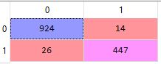Accuracy: 97%

Sensitivity: 94%

Precision: 96%

RF performs so well even without tuning since it is good at interpreting results even with missing data. Furthermore, it takes into account only small subsets of the training set for every tree. This helps to form clear cut ideas about the possibility of the target variable.

1. With tuning:

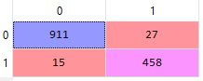Accuracy: 97.02%

Sensitivity: 96.8%

Precision: 94%

Tuning helped us slightly improve our recall (or sensitivity) value. But we must not overlook the benefits of this slight improvement since even one misclassification of a failure as success might cause huge loss in terms of capital or even lives (for example, if the devices are for medical purpose or air buses)

1. With tuning and recursive feature selection:

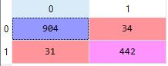Accuracy: 95.4%

Sensitivity: 93.4%

Precision: 92.8%

The disadvantage of Recursive Feature elimination can be easily demonstrated from this observation. On selecting the 5 optimum features, our sensitivity and accuracy reduced unexpectedly. It is often observed that choosing optimal features helps the model predict better. However, it clearly did not work for this case.

This is so since RFE is not completely automated. The designer has to specify the number of optimal features he/she wants from the RFE algorithm. This may lead to pruning of features which leads the algorithm to better results, even if they are not the best features for the job. Also the selection criteria in no way favors Recall, which is our prime objective: reduction of Failures misclassified as Success.

1. With tuning and customized iterative feature selection:

Accuracy: 97.02%

Sensitivity: 96.8%

Precision: 94%

After elimination on non-contributing features, we re-tune the parameters according to the remaining features. Following are the top combinations of hyper parameters:

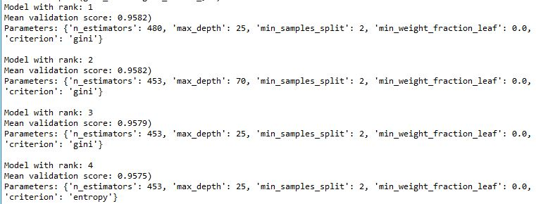

On applying the said parameters with a bit of manual modification (via trial and error method), it is found that 96.8% is the highest sensitivity possible.

This is not an improved performance, and is in fact, same as point (ii), where we have applied the tuned values with ALL the features. Even though we see no improvement in performance for RF algorithm, it is not always so with the other algorithms. RF itself is a very good algorithm which does not need the aid of external feature selection most of the time since it picks a few features at a time to obtain the results. But as already seen here, IFE rapidly increases Sensitivity for algorithms which are not as competitive as RF for this specific dataset (Competence of algorithms vary depending on the dataset).

However, there is of course one significant advantage other than improved performance. The Feature Selection technique reduces the feature set, which in turn reduces the computational expense of the RF algorithm, and still gives the best performance possible.

3.b.3 Support Vector Classifier

Model Overview and Intuition: Support Vector (Ctrl+Click to move to required page)

The main job of the Support Vector Classifier is to find the plane or line which separates our classes optimally. This can be done in several ways by the svc. The SVC employs ‘kernels’ to put the several ways into effect. Kernels help us manipulate the line or plane of division as per the classes of the data points.

In a simple dataset, it may be possible to divide the classes by a simple line (Via ‘linear’ kernel). However, when our dataset gets more complicated and does not show any linear relation, we obviously cannot use a linear division criterion. To solve this problem, simple solutions like manipulation of the line (or plane) of division can be employed. For example, if we use a ‘poly’ (polynomial) kernel instead of a linear one, we will be able to map the data into an ‘n’ dimensional space by the simple usage of exponents of ‘n’, Similarly, Gaussian helps us map the data in a higher dimension of space so that we can effectively plot the patterns which were initially indiscernible in a lower dimension.

Follow this [link](https://towardsdatascience.com/understanding-the-kernel-trick-e0bc6112ef78) for an in-depth understanding.

Implementation:

First step was to preprocess the data set which is done by our general preprocess module. Next comes the classifier based feature elimination. RFE is not a very effective tool for this purpose as has been already mentioned. Furthermore, RFE does not work for SVC since this algorithm fails to provide the coefficient and feature importance in the scikit implementation.

Thus, we fall back to our customized iterative feature elimination procedure. On applying the same we get the following features eliminated.

Initial sensitivity **with no feature elimination or parameter tuning: 71.4%** (poor for high-risk model)

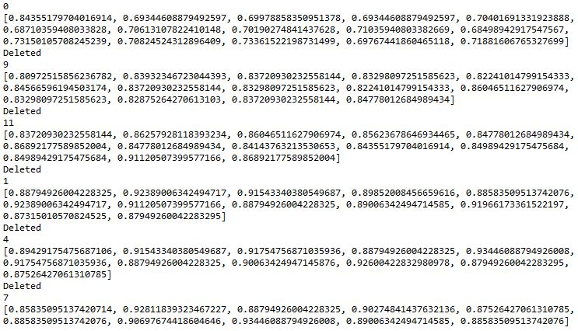

After feature selection our **sensitivity improves up to 93.44%.**

Thereafter comes the process of parameter tuning (Or parameter sweeping in popular terms). We tune the hyper parameters of the Support Vector Classifier through Grid Search. Demonstrated as follows:

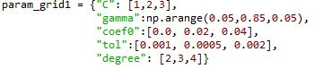

**(Explanation of the parameters from scikit learn documentation)**

**C:**float, optional (default=1.0)

Penalty parameter C of the error term.

**kernel:**string, optional (default=’rbf’)

Specifies the kernel type to be used in the algorithm. It must be one of ‘linear’, ‘poly’, ‘rbf’, ‘sigmoid’, ‘precomputed’ or a callable. If none is given, ‘rbf’ will be used. If a callable is given it is used to pre-compute the kernel matrix from data matrices; that matrix should be an array of shape (n_samples, n_samples).

**degree:**int, optional (default=3)

Degree of the polynomial kernel function (‘poly’). Ignored by all other kernels.

**gamma:**float, optional (default=’auto’)

Kernel coefficient for ‘rbf’, ‘poly’ and ‘sigmoid’. If gamma is ‘auto’ then 1/n_features will be used instead.

**coef0:**float, optional (default=0.0)

Independent term in kernel function. It is only significant in ‘poly’ and ‘sigmoid’.

**probability:**boolean, optional (default=False)

Whether to enable probability estimates. This must be enabled prior to calling *fit*, and will slow down that method.

**shrinking:**boolean, optional (default=True)

Whether to use the shrinking heuristic.

**tol:**float, optional (default=1e-3)

Tolerance for stopping criterion.

**cache_size:**float, optional

Specify the size of the kernel cache (in MB).

**class_weight:**{dict, ‘balanced’}, optional

Set the parameter C of class i to class_weight[i]*C for SVC. If not given, all classes are supposed to have weight one. The “balanced” mode uses the values of y to automatically adjust weights inversely proportional to class frequencies in the input data as n_samples / (n_classes * np.bincount(y))

The following visual results are obtained regarding the performance of the range of hyper parameters that we initially provided in the parameter grid dictionary:

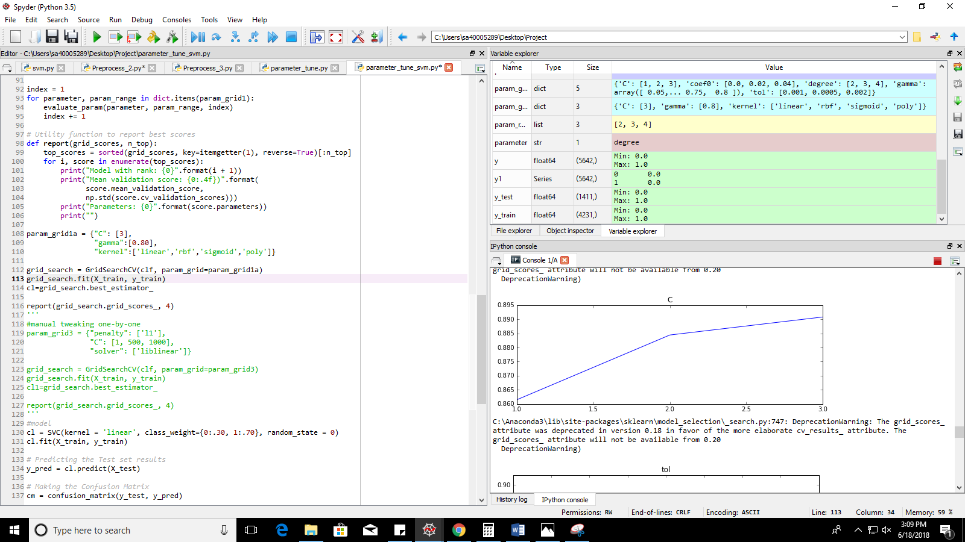

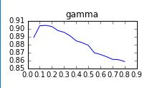

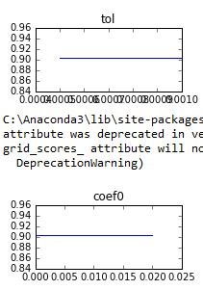

After using the obtained parameters and with a bit of manual trial and error, we obtain the following confusion matrix, which is a further improvement on sensitivity.

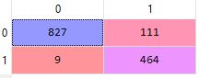Accuracy: 91.4%

Sensitivity: 98.1%

Precision: 80.7%

Final set of parameters in the model:



Class weights are decided based on the ratio of one class to another, which can be calculated by simple a simple python implementation. Manual tweaking also involved (as is observed with C)

In parameter tuning we observed that C will give best results if its value is set at 3. It in fact, improves accuracy and precision a lot. However, it compromises on the sensitivity which we cannot afford. Thus, the value of C is brought back to 1 by the trial and error method.

Confusion Matrix with C=3:

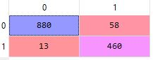Accuracy: 94.9%

Sensitivity: 97.2%

Precision: 88.8%

4. CONCLUSION

It can be inferred that Support Vector Classifier gives us the best recall value and ensures that there is minimum misclassification of true failure as false success. (Recall: 98.1%) However, it compromises on misclassification of true success as false failure. (low precision: 80.7%)

Random Forest on the other hand, gives a far better overall accuracy. It ensures both high sensitivity (although not as high as with SVC) and precision. (Recall: 96.8%; Precision: 94%).

It is thus evident that Random Forest Classifier is a more concrete classifier with regard to our present dataset. The difference in sensitivity better the RF and SVC implementation is about 1.2% (which is very insignificant). But, keeping in mind the risk factor of the devices used, the user may choose the model accordingly.

If the devices are extremely vital, SVC is the best choice (as per experimentation) since it crucial to detect the failure before actual date of expiry and a false alarm is way less harmful.

If the devices are not as vital as the above situation, and are perhaps extremely expensive, then Random Forest is the best choice (as per experimentation) since it minimizes false alarms (which leads to less loss in terms of unnecessary replacements) and also gives a fair prediction of true device failures.